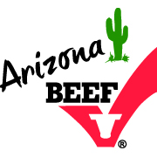

Beef Websites
www.beeflessons.com
Beef lesson plans complied from across the country

www.explorebeef.org/grasstograin.aspx
An interactive game to explore what cattle eat

www.myamericanfarm.org/classroom/games
The Steaks are High is a game about the beef lifecycle with math mixed in

www.enasco.com/page/FCS/lessons/fcs_lesson32
Lesson plans geared for culinary and FCS classes which could easily be tailored to other ages/ subjects

www.ArizonaBeef.org
Arizona Beef Council

www.FactsAboutBeef.com
Facts and myth busters about beef and raising cattle

www.beeflessons.com
Beef lesson plans complied from across the country

www.BeefItsWhatsForDinner.com
The consumer go-to for beef recipes, cooking information, nutrition, cut search

www.BeefInnovationsGroup.org
Animated Cutting Demos

#AZbeef
Facebook
Beef. It’s What’s for Dinner
Arizona Beef

Twitter
@Beef
@ArizonaBeef
@BeefFacts
@BeefPros

Instagram
@ArizonaBeef
@BeefPros

