Why Alternate Containers?

- Poor soil conditions

- Mobile population

- Expense

- Variety

- Simplicity

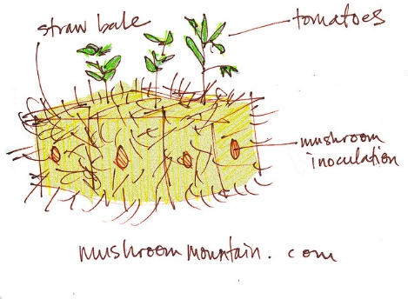

Sources

- Farm Bureau

- State AITC

- Ag Extension Office

- Internet

- Pinterest

- Facebook

- Bookstore

- ASK people in the community

- Read seed packets

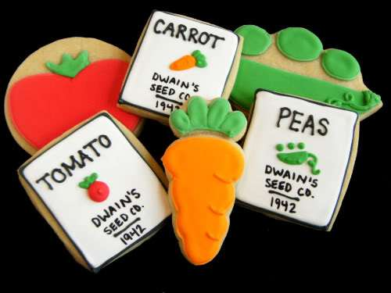

Teaching Points

- We are ALL agriculturists

- NO ONE is an expert here

- Always try something new

- Never give up….just reroute!

- Mistakes are OK….we learn by DOING

- HAVE FUN- Get dirty

- Garden Without Gloves

Key Phrases

- Supplement your table

- Garden without gloves

- Get dirty

- Grow SOMETHING

- NEVER be afraid of DIRT

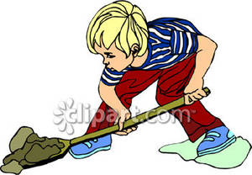

Grasses In Classes
- Salt Marsh

- Shoreline Restoration

- Smooth Cord grass

- Water Sources/Resources

- Water Quality

- Oil Spill Affect

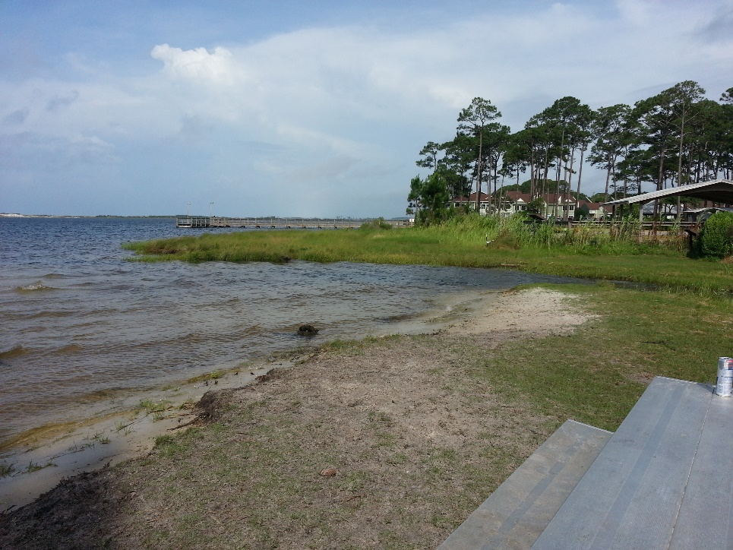

African Keyhole Garden
- Self-Feeding Raised Bed

- Compost in Center

- Can Control Water Use

- Easily Adapted to Area

- Any Materials

- Global Perspective for Students
