Plant Part
Plant Name | Plant Part | Nutrition Fact | Picture
Carrots | Root | Very Good Source of Vitamin A | 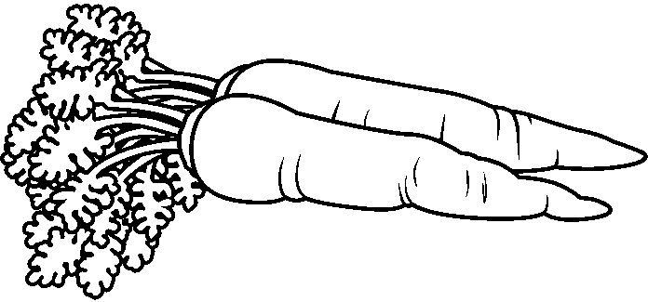
Sweet Potato | Root | Very Good Source of Vitamin A | 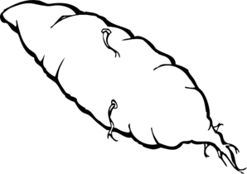
Asparagus | Stem | Very Good Source of Vitamin E | 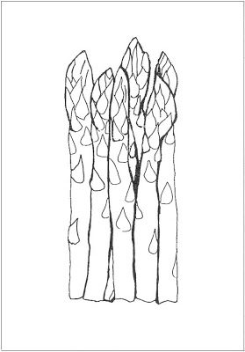
Spinach | Leaf | Very Good Source of Vitamin K | 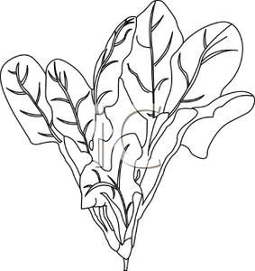
Broccoli | Flower | Very Good Source of Vitamin C and Vitamin K | 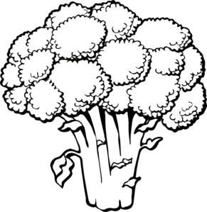
Tomatoes | Fruit | Good Source of Vitamin E | 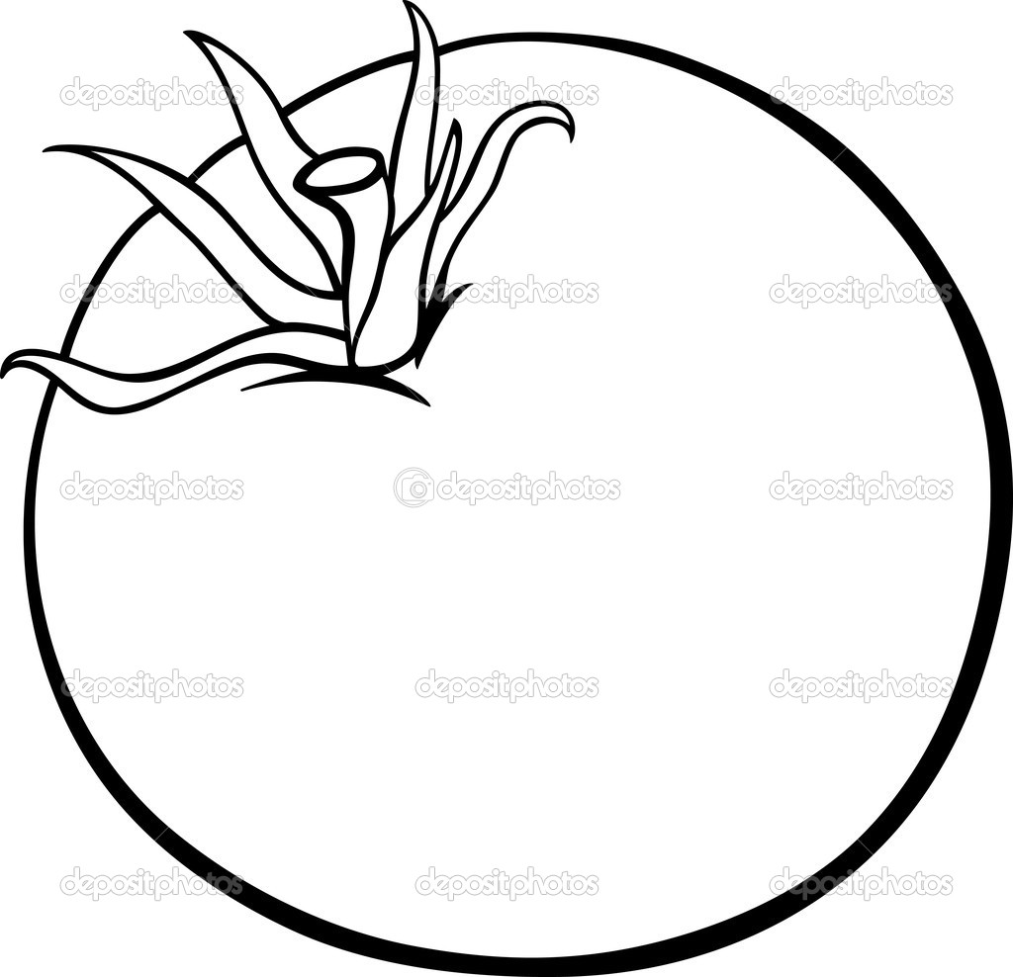
Zucchini | Fruit | Very Good Source of Dietary Fiber
Corn | Seeds | Good Source of Vitamin B6 and  Omega-6 Fatty Acids | 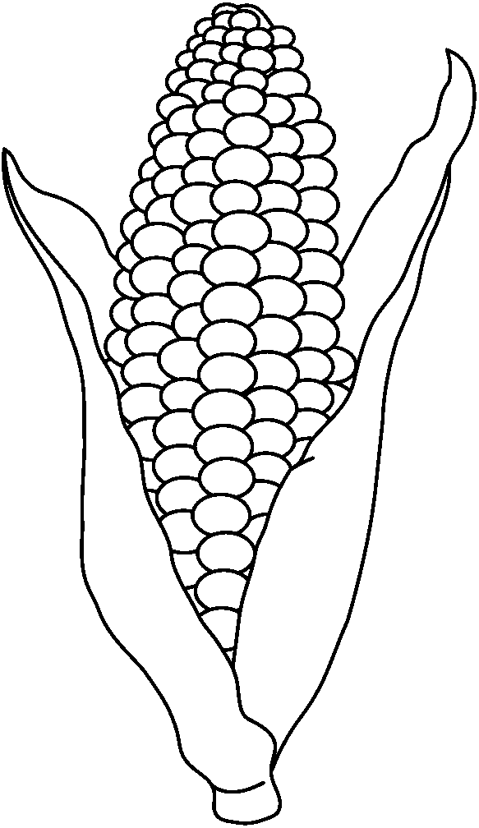
Fruit
Fruit | Classification | Nutrition Fact | Picture
Blueberries | True Berry | Very Good Source of Vitamin C | 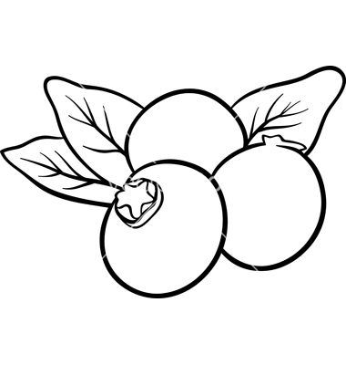
Cantaloupe | Pepo | Good Source of Dietary Fiber | 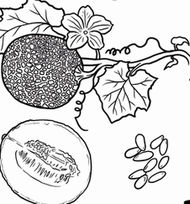
Grapefruit | Hesperidium | Good Source of Vitamin A | 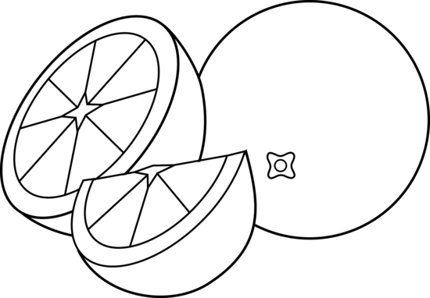
Grapes | True Berry | Good Source of Vitamin K | 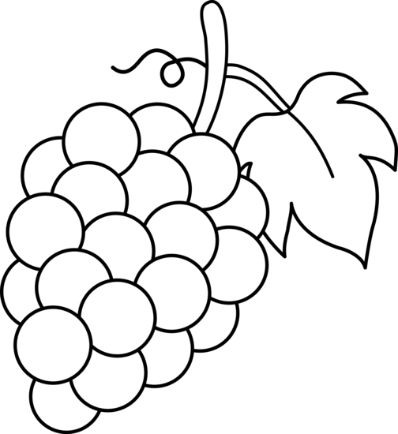
Peaches | Drupe | Good Source of Vitamin C | 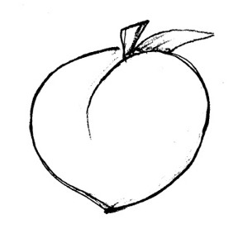
Pears | Pome | Very Good Source of Dietary Fiber | 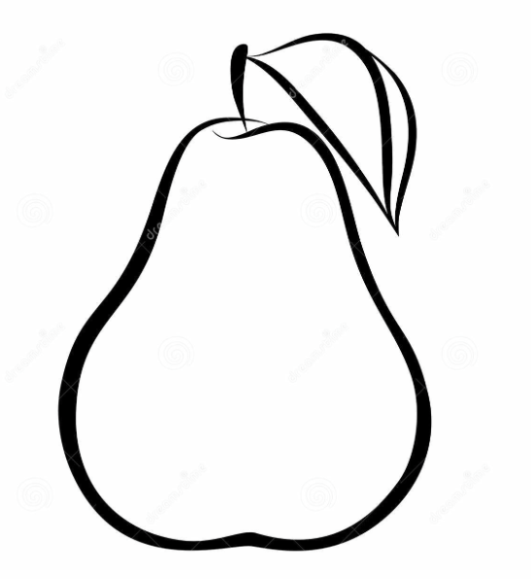
Pineapple | Multiple | Good Source of Vitamin B6
Strawberries | Aggregate | Good Source of Potassium

