Plant Parts

Plant Part | Function | Picture
_ _ _ _ | Anchors plant in soil  Absorbs water from ground  Stores food reserves | 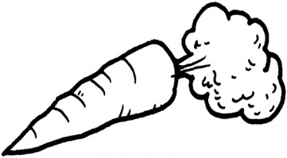
_ _ _ _ | Supports plant | 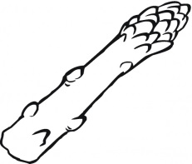
_ _ _ _ | Site of photosynthesis | 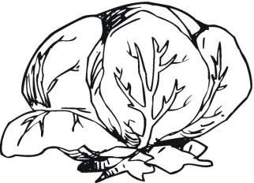
_ _ _ _ _ _ | Reproductive structure  Attracts pollinators | 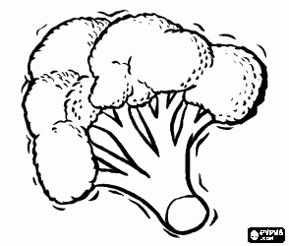
_ _ _ _ _ | Contains seeds  Food source  Means of seed dispersal | 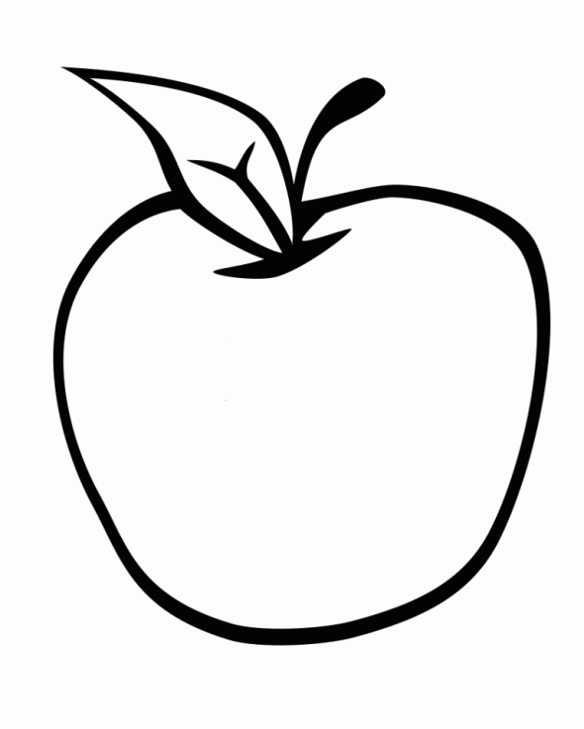
_ _ _ _ | Encloses and protects the baby plant  Grows into a new plant  Stores energy for new plant | 