Plant Parts

Plant Part | Function | Picture
ROOT | Anchors plant in soil  Absorbs water from ground  Stores food reserves | 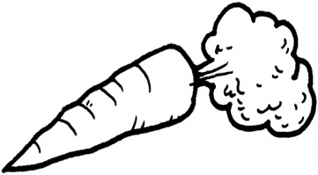
STEM | Supports plant | 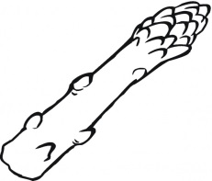
LEAF | Site of photosynthesis | 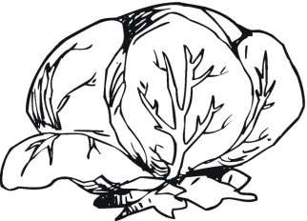
FLOWER | Reproductive structure  Attracts pollinators | 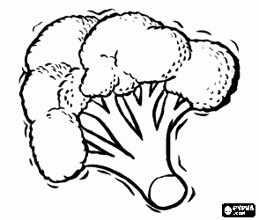
FRUIT | Contains seeds  Food source  Means of seed dispersal | 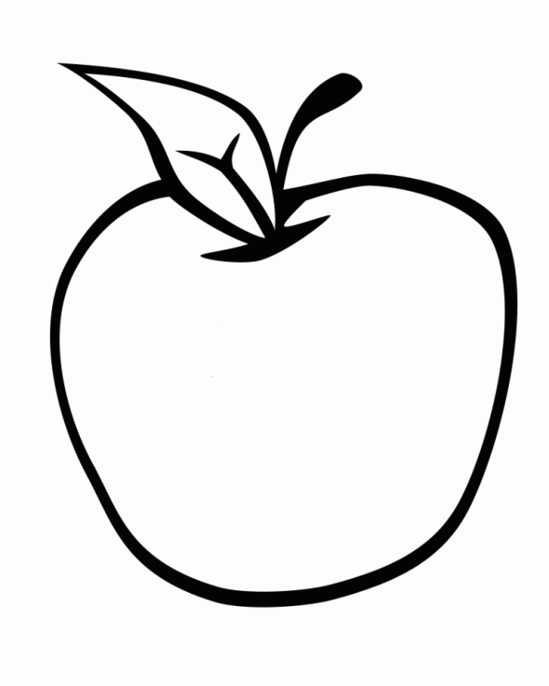
SEED | Encloses and protects the baby plant  Grows into a new plant  Stores energy for new plant | 