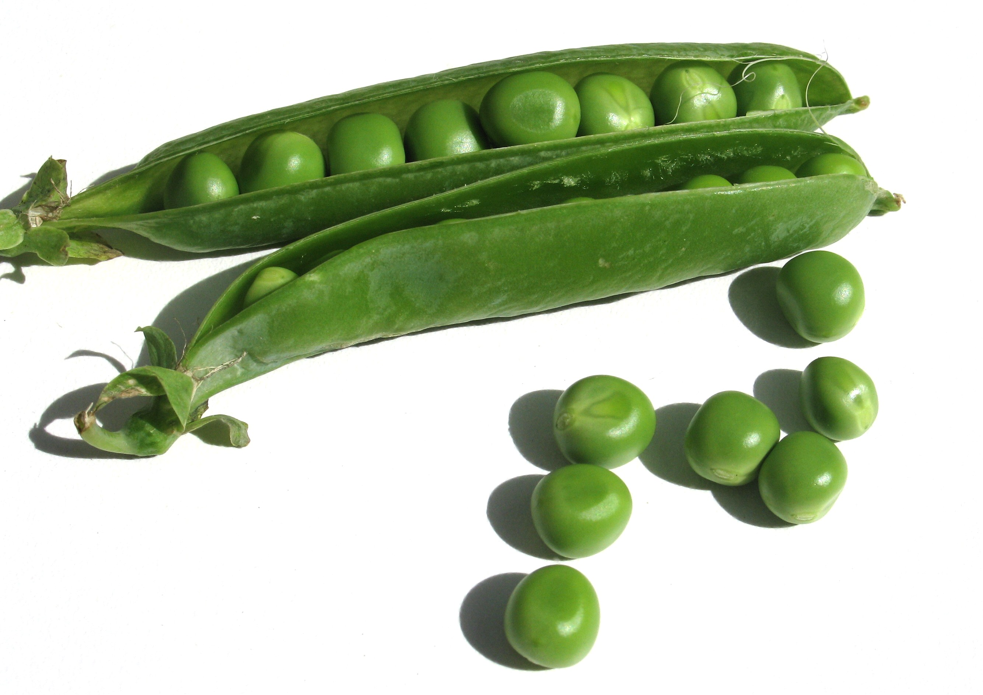
Across:  - Attracts Pollinators  3. Supports plant  4. Site of photosynthesis | Down:  - Means of seed dispersal  - Absorbs water from the ground  - Stores energy for new plant
Plant Parts
Use hints and word bank to complete the crossword
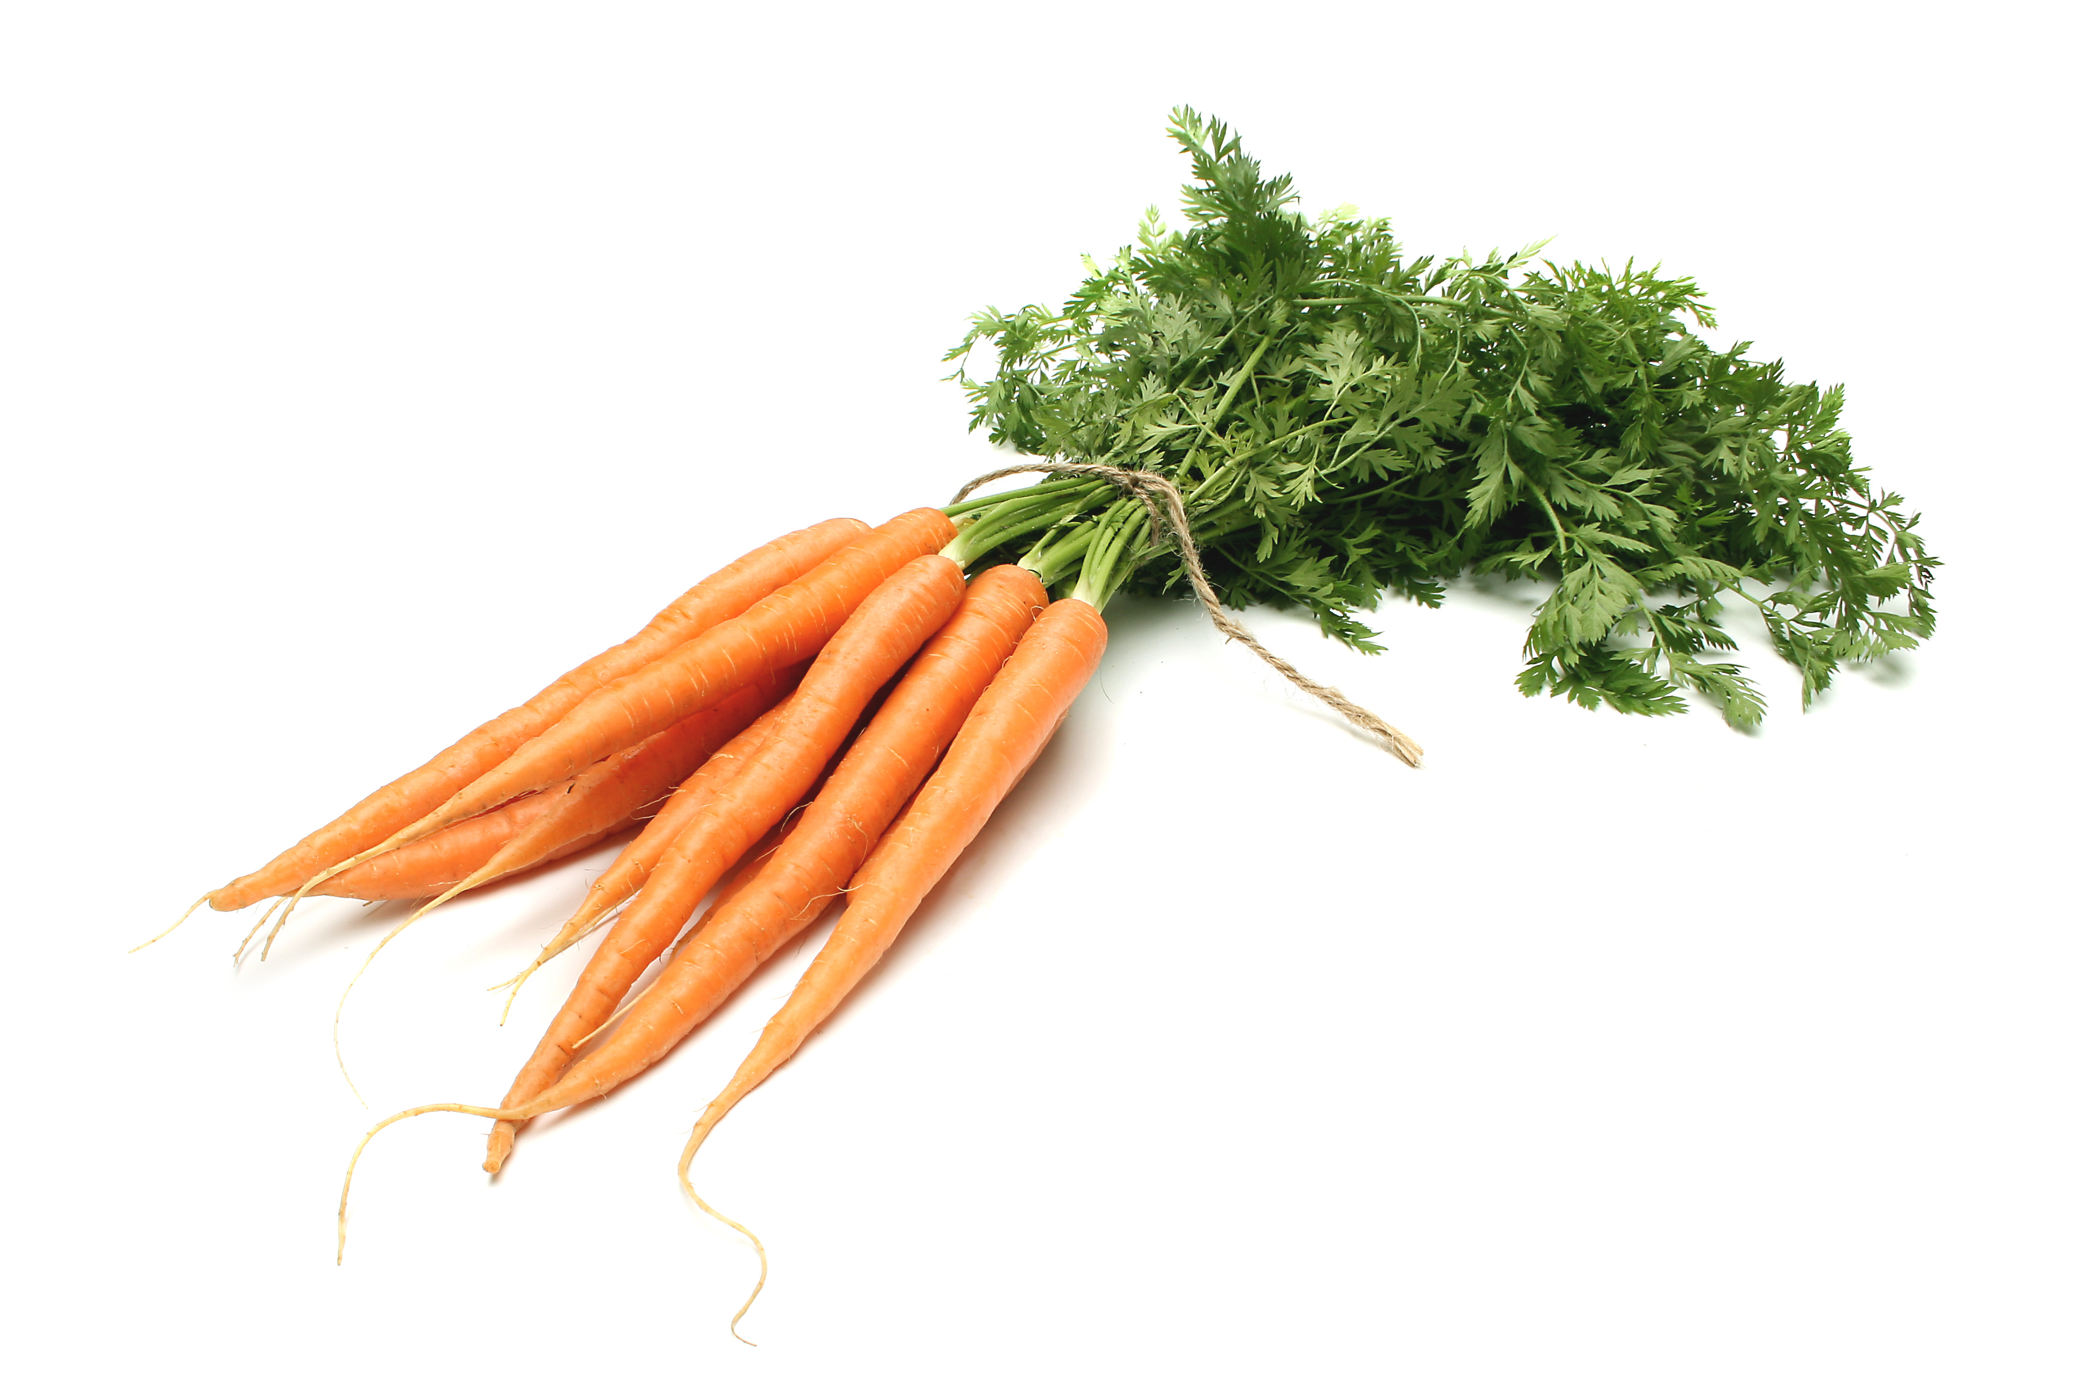

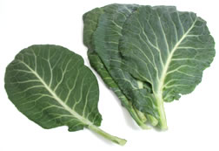
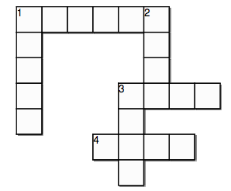
Fruit Seed Root
Leaf Stem Flower

