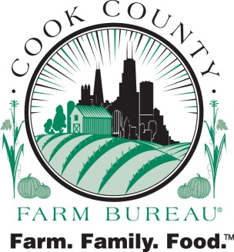

SAMPLE

Dear Parent/Guardian,

Today was the last day of our camp! We had fun learning about plants, farm machines and soybeans. Mr. Greg Stack (Univ of IL educator) brought cool plants to see and smell, Jon Drover from Hintzsche Fertilizer taught us about farm machines and Ag in the Classroom presenter, Joan Ramsey, did cool soybean activities with us. During our closing we talked about pizza and where it comes from. Your child is bringing home an Ag Mag that tells you all about pizza. We have Ag Mags as part of our website: [www.cookcfb.org](http://www.cookcfb.org) . Go to Ag Literacy and “teacher resources” where you will see them listed. Please tell your child’s classroom teacher about us as we come to schools too!

We hope your child enjoyed their experience during our Passport to the Farm Camp. We hope you filled out the RED evaluation form that was sent home yesterday. If not, please send a quick email note to me just to let me know what your child liked and any suggestions for next year if we are able to offer this again. My email is [aitc@cookcfb.org](mailto:aitc@cookcfb.org). This is the second year the Cook County Farm Bureau Foundation was able to sponsor this wonderful program. Any and all feedback can be sent to the address below.

Thank you for sending your child to our camp! We hope this will open their eyes to the vast opportunities in the world of agriculture. 1 in 4 children will end up in a career related to ag.

Sincerely,

cid:image001.png@01CE795B.CF8A1140

Ag Literacy Coordinator

Cook County Farm Bureau®

6438 Joliet Road

Countryside, IL  60525

[aitc@cookcfb.org](mailto:aitc@cookcfb.org)

708-354-3276