**SAVE THE DATE-SAVE THE DATE**

**Who: Lebanon Road Elementary**

**What: Agriculture Science Night**

**When: Thursday, Nov. 6th**

**Time: 5:30-7:00**

Join us for an exciting night as we investigate the influence agriculture has on science. Be prepared to participate in hands on science investigations, taste the commodities of NC, and build your very own “mini” greenhouse.

[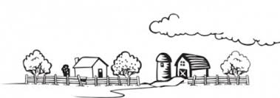](http://www.google.com/url?sa=i&rct=j&q=&esrc=s&frm=1&source=images&cd=&cad=rja&uact=8&ved=0CAcQjRw&url=http://br.freepik.com/vetores-gratis/coloring-book-farm-clip-art-paisagem_376884.htm&ei=dzpIVPGMCcXHgwS154GADw&bvm=bv.77880786,d.eXY&psig=AFQjCNENcPIBG9pC7veLn3r5ZlGcPxb5Rw&ust=1414105797904272)

Lebanon Road Agriculture Science Night is sponsored by:

 [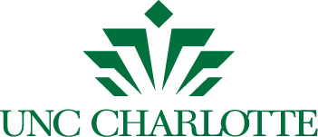](http://advancement.uncc.edu/sites/advancement.uncc.edu/files/media/unc-charlotte-logo.zip)

**SAVE THE DATE-SAVE THE DATE**

**Who: Lebanon Road Elementary**

**What: Agriculture Science Night**

**When: Thursday, Nov. 6th**

**Time: 5:30-7:00**

Join us for an exciting night as we investigate the influence agriculture has on science. Be prepared to participate in hands on science investigations, taste the commodities of NC, and build your very own “mini” greenhouse.

[](http://www.google.com/url?sa=i&rct=j&q=&esrc=s&frm=1&source=images&cd=&cad=rja&uact=8&ved=0CAcQjRw&url=http://br.freepik.com/vetores-gratis/coloring-book-farm-clip-art-paisagem_376884.htm&ei=dzpIVPGMCcXHgwS154GADw&bvm=bv.77880786,d.eXY&psig=AFQjCNENcPIBG9pC7veLn3r5ZlGcPxb5Rw&ust=1414105797904272)

Lebanon Road Agriculture Science Night is sponsored by:

 [](http://advancement.uncc.edu/sites/advancement.uncc.edu/files/media/unc-charlotte-logo.zip)