**Lebanon Road Elementary School**

**First Annual**

**Agriculture Science Night**

**Thursday, November 6th, 2014**

**5:30 pm -7:00 pm**

***How are science and agriculture connected?***

Bring the family and find out! Investigate seeds, build mini green houses, learn about genetics, and taste food grown right here in North Carolina.

Be inspired to care for the land and appreciate how important science and agriculture in North Carolina are to the well being of our families.

***Special Thanks to Lebanon Road Elementary***

Agriculture Science Night Partners

[](http://research.ncsu.edu/ges/events/)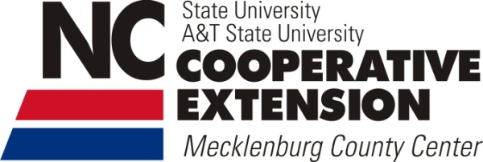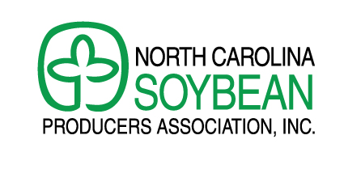[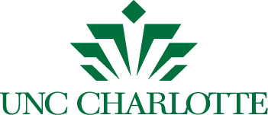](http://advancement.uncc.edu/sites/advancement.uncc.edu/files/media/unc-charlotte-logo.zip)

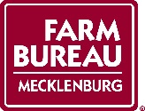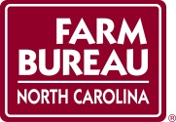

***A*g in the Classroom**