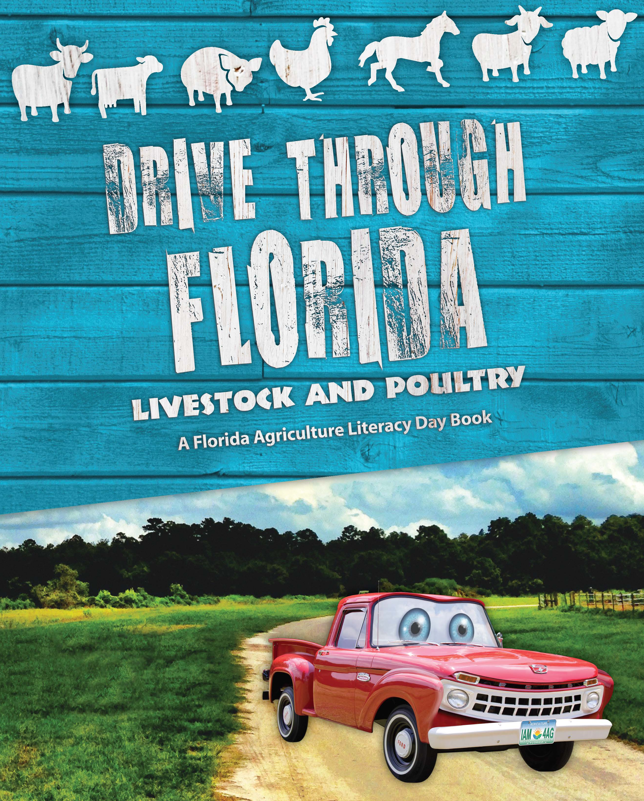
Name:
Date:

Drive through Florida
Livestock & Poultry

- What is the name of the truck?

- Where does the trip start?

- Who first brought cattle to Florida?

- We have more than dairy farms in Florida?

- are female hogs, and are male hogs.

- Name three birds that are included with chicken in the poultry family?

- Which county has the most horses?

- Why were horses important to Florida's first settlers?

- What shape is the pupil in a goat's eye?

- Is a “hair sheep” used for meat or wool?

