Tasty Ag Connections to Writing
Presented by Ginger Deitz and Jill Vigesaa
Representing North Dakota Ag in the Classroom

Come on a picnic with us and let us show you how to use our menu to make tasty connections to the writing process! Analogies are a powerful brain strategy for teaching complex concepts that are compared to dissimilar ones the student already knows. The brain is a "maker of meaning" and is constantly searching for connections and patterns between the new and the known. Students already know the sensation of a juicy hamburger, sweet refreshing watermelon, and the crunchy delight of an Oreo cookie. We'll use agriculture analogies that make a tasty treat for brain power that leads to fun writing strategies.

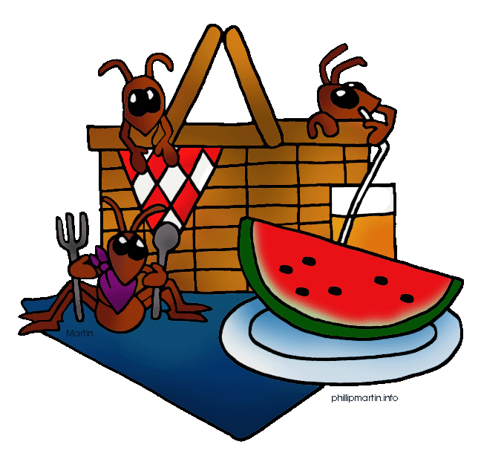

June 18th is International Picnic Day!

International Picnic Day Fun Facts:

- The first appearance of the word "picnic" in print can be found in the 1692 edition of Tony Willis's, Origines de la Langue Française, which mentions "pique-nique" as being a group of people in a restaurant who brought their own wine. In other words, BYOB
- Picnics evolved from elaborate traditions of moveable outdoor feasts enjoyed by the wealthy to small-scale occasions enjoyed by anyone.
- In 2000, about 4,000,000 people attended a picnic in France that was about 600 miles long (about 1,000 kilometers long) to celebrate the first Bastille Day of the new Millennium.
- The longest picnic line measured 2,277 meters and was organized in Kitchener, Ontario, Canada, on July 15, 2012, as part of the Kitchener Cityhood Centennial Celebration.
- The 1955 film Picnic was a multiple Oscar winner. The film has been remade twice, in 1986 and 2000.
International Picnic Day Joke:
There were these two AITC Presenters, Ginger and Jill, who were driving along the highway looking for a place to stop and picnic. Ginger said to Jill, "Let's stop here, and have our picnic under that tree." Jill said, "No! Let's have it right here in the middle of the road." They fought for a bit, but finally agreed to have it in the middle of the road. All of a sudden, a car came speeding towards them and had to swerve into the tree to keep from hitting them. Jill said to Ginger, "See? If we were under that tree, we'd be dead now!"
Source:
www.weirdholiday.com/2013/06/international-picnic-day-june-18th.html
To find a National Food Holiday for every day of the month, visit the Foodimentary Website! www.foodimentary.com

The Hamburger Way of Writing Juicy Paragraphs
You can write a great paragraph if you just follow the right steps in the right order. Use this form to write a paragraph on any topic using the “Hamburger Writing Metaphor”. The following resources are useful when introducing this writing strategy to your students:
http://www.pequannock.org/ Type in search box “Hamburger Paragraph PowerPoint”
https://view.officeapps.live.com/op/view.aspx?src=http%3A%2F%2Fwww.marshallmiddle.org%2Fapps%2Fdownload%2F2%2FvNu05EzqhAcZI9KZWHwgE3VE4Zky1i8aEwFV0OIXMdtO2Qb9.ppt%2Fparahamburger_paragraph.ppt
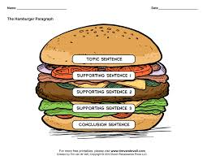
www.youtube.com/watch?v=TmOSppCyMxQ created by Cindy Beck.

- What is your topic? Write a juicy “grabber” sentence!
- List several details that will support, explain, or prove what you want to say about your topic sentence.
- What is your conclusion (the topic sentence rewritten)?

Let’s make a list of details that you think will say what you want about your topic:
a.____________________________________________________________________________
b.____________________________________________________________________________
c.____________________________________________________________________________
d.____________________________________________________________________________
e.____________________________________________________________________________
f.____________________________________________________________________________
g.____________________________________________________________________________
Now decide which details do the best job of helping you with what you want to say about your topic. Which ones are the most interesting and tell the most important things about your topic? Which details do the best job of explaining, proving, or supporting your topic sentence? Draw a circle around the letters of the details you want to use in your paragraph.
It’s time to write your paragraph using the “sandwich technique”! Start your paragraph with your topic sentence. Fill in the middle with your details. End with your conclusion. You---yes, YOU---can write a great paragraph if you just follow the right steps in the right order!
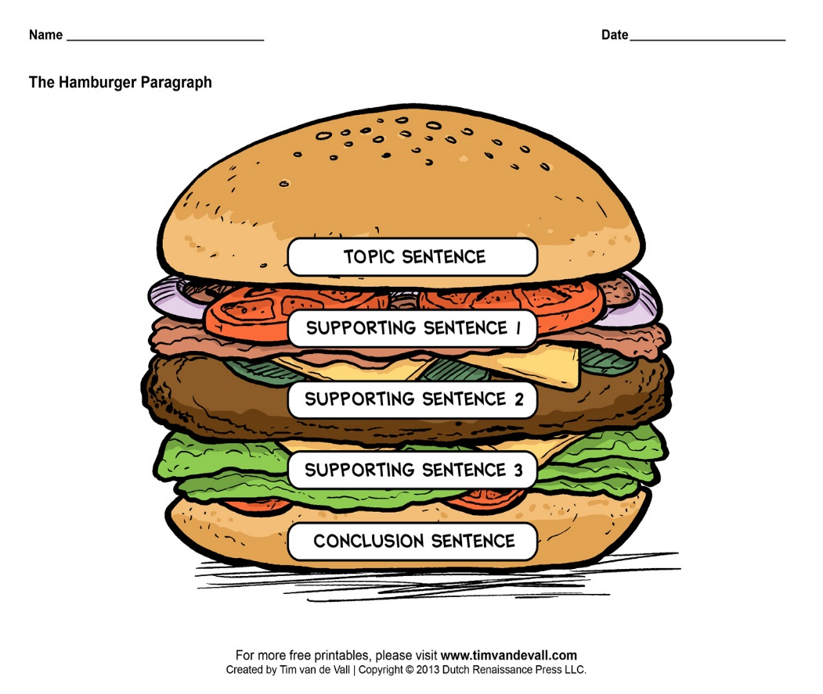
____________________________________________________________________________________________________________
____________________________________________________________________________________________________________
____________________________________________________________________________________________________________
_______________________________________________________________________________________________________________________________________________________________________________________________________________________________________________________________________________________________________________________________________________________________________________________________________________________________________________________________________________________________________________________________________________________________________________________________________________________________________________________________________________________________________________________________________________________________________________________________________________________________________________________________________________________________________________________________________________________________________________________________________________________________________________________________________________________________________________________________________________________________________________________________________________________________________________________________________________________________________________________________________________________________________________________________________________________________________________________________________________________________________________________________________________________________________________________________________________________________________________________________________________
____________________________________________________________________________________________________________
____________________________________________________________________________________________________________
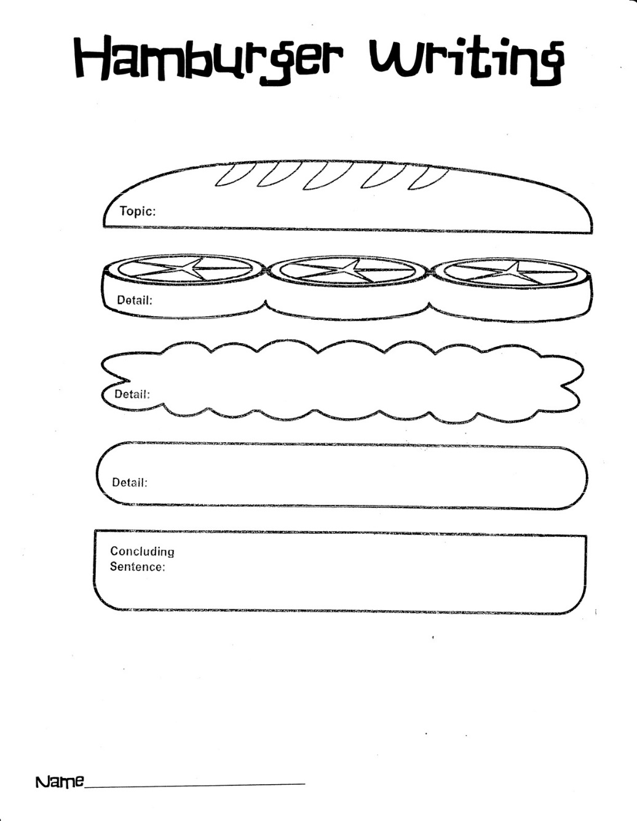
Topic:
Detail:
Detail:
Detail:
Concluding Sentence:

Managing Writers’ Workshop Using the Sandwich Theory
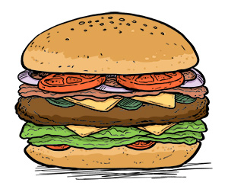
Begin with a positive comment
List helpful suggestions
End with a positive comment
Writing Process
- Prewriting
- Drafting
- Peer Conferencing
- Revising
- Editing
- Teacher Conferencing
Tony
Jill

Cathy

Alex

To manage one’s writing workshop within the classroom you want to devise a procedure that emphasizes individual learning. Because students are continually working on different steps of the writing process, the above management chart that lists the six steps of the writing process works well. Each child has a clothespin with his/her name, and at the beginning of the workshop, each student clips their clothespin to the step that they are working on for that day. The teacher can easily see who will be working independently, with a peer, or who is ready for teacher conferencing.

The third step in the writing process is “Conferencing” and this is to be done with the student’s peers. I ask the writer to find two classmates that will use the Sandwich Theory as they listen to the story. The first step (top bun) reminds peer editors to list a few positive comments about the piece to develop rapport among the three collaborators. The middle of the sandwich (the meat, lettuce, cheese, etc.) tells the peer editors to list helpful suggestions so the author can make improvements to the writing. The third step (bottom bun) reminds the editors to end the conference with another positive comment or comments that summarizes the best points of the author’s work so far. Now, the author is ready for the revision stage.

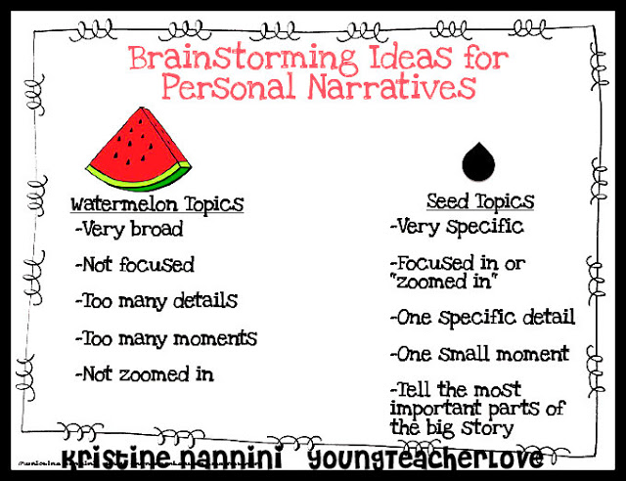
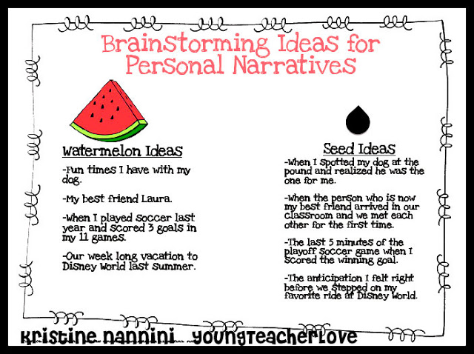
Additional Resource: Power Point “Small Moment Writing” http://it.pinellas.k12.fl.us/Teachers3/gurianb/files/8B6B49A6609B4F2D808986BD691DDB9B.ppt
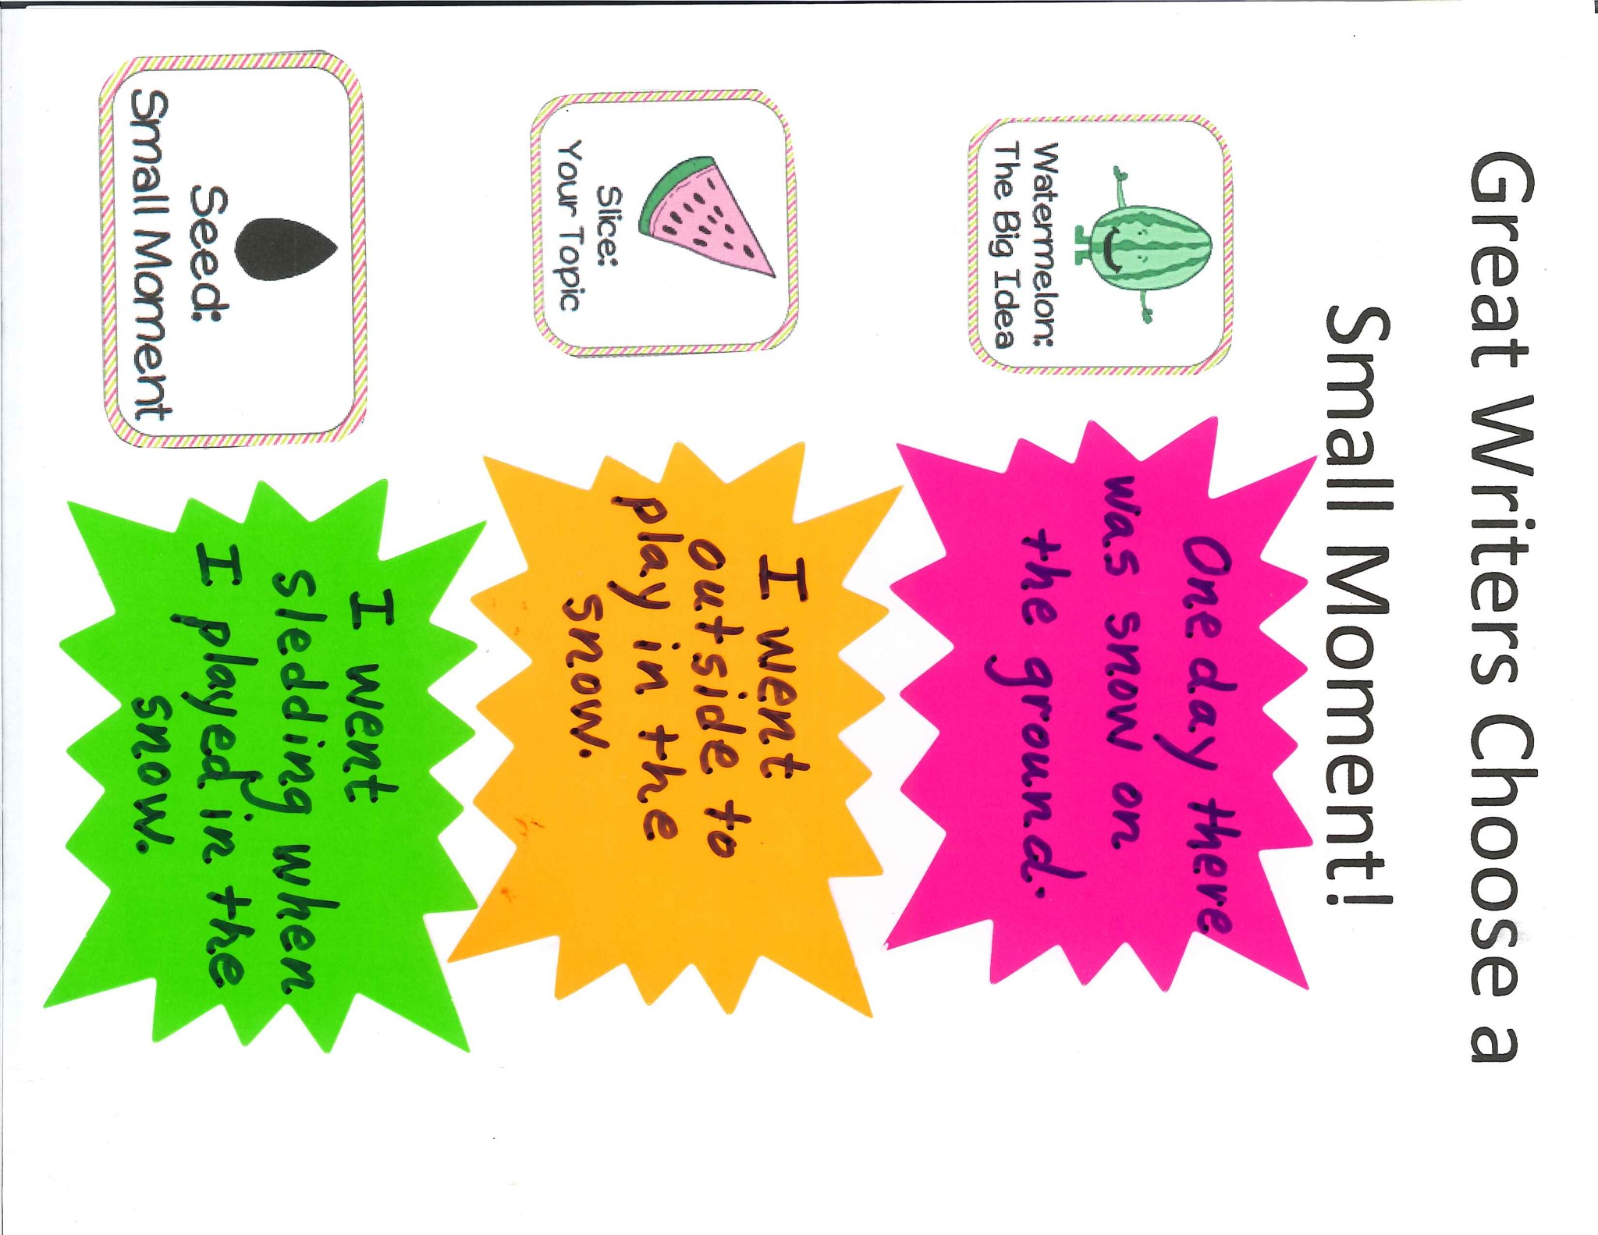
Name ________________
…..or is this a seed story?
A seed story is a smaller story that focuses on ONE event.
Is this a watermelon story…….
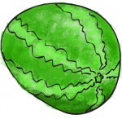
A watermelon story is a big story with MANY events.

The best personal narratives are SEED stories!
Directions: Read each story idea. Determine whether the story idea is a “watermelon story” or “seed story.” Circle the correct word.

- My trip to Chicago Watermelon Seed
- My summer at Grandma’s house Watermelon Seed
- Breaking open my piñata Watermelon Seed
- Choking on a piece of meat Watermelon Seed
- A day I went shopping with my aunt Watermelon Seed
- When I got lost at the mall Watermelon Seed
- The time I broke my arm while riding a skateboard Watermelon Seed
- The first day of school Watermelon Seed
OREO OPINION WRITING
O
Opinion – Give your opinion

R
Reason – Give the reason for your opinion

E
Example – Give an example to support your opinion
O
Opinion – Restate your opinion

Common Core Graphic Organizer-OREO Opinion Writing

CCSS.ELA-Literacy.W.1.1 Write opinion pieces in which they introduce the topic or name the book they are writing about, state an opinion, supply a reason for the opinion, and provide some sense of closure.

CCSS.ELA-Literacy.W.2.1 Write opinion pieces in which they introduce the topic or book they are writing about, state an opinion, supply reasons that support the opinion, use linking words (e.g., because, and, also) to connect opinion and reasons, and provide a concluding statement or section.

CCSS.ELA-Literacy.W.3.1 Write opinion pieces on topics or texts, supporting a point of view with reasons.

