Activity 1: What Determines a Worker Bee’s Role in the Hive?

A hive is in constant need of materials such as pollen, water, and nectar. Worker bees forage to supply the hive with these materials. As the colony’s needs change, so do the resources that are collected. Pollen serves as a protein source and is needed in greater abundance when the colony has young offspring. Nectar is a carbohydrate which serves as an energy source. Water is brought back and evaporated to keep the colony cool on a hot day.
Figure 1: Worker bee with plastic numbered tag
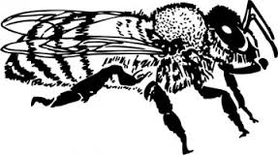
A student wondered if worker bees shared equally in bringing each type of material to the hive or if there was a division of labor where workers were specialized for different materials. To determine which was correct, the student set up an experiment. To monitor the behavior of specific bees, the student glued plastic, numbered tags to 50 worker bees. She monitored foraging activity at the hive entrance. The student recorded which resources each numbered bee brought back to the nest in her field notes.
17

- What is the student’s research question?

- Form a hypothesis for the research question.

Use the researcher’s data in the field notes to complete the data table.
Table 1:
Bee number | Time Point 1 | Time Point 2 | Time Point 3 | Time Point 4
- Categorize the bees by their number into two groups. Why did you group them in this manner?

- Does this data suggest that there is a division of labor in the hive? Explain.

- At what point in the day was water was returned to the hive? Suggest a reason.

- Bees #26, 34, and 44 returned empty on at least one of their foraging trips. Do you think this is related to the time of day that bees foraged? Explain.

- Suggest a reason why Bees 26, 34, and 44 might have returned to the hive empty.

From the previous data, you should have concluded that there are two strains of bees: those that forage for nectar and those that forage for pollen and water.

- Why might worker bees be divided into two strains? Discuss and list 3 possible reasons.

Activity 2: Learning about the Proboscis Extension Response (PER)

The student wonders if a honey bee’s foraging behavior is related to their ability to detect sugar. The student hypothesizes if a bee is a nectar collector, then that bee is more likely to be able to detect high concentrations of sugar. Conversely, if a bee is a pollen or water collector, then that bee is more likely to respond to a lower concentration of sugar. Scientists measure a bee’s ability to detect sugar using the proboscis extension response (PER). Watch this video to see a researcher perform a PER test: https://youtu.be/-_cXqda1BZA

A bee’s antenna is a sensory organ that tastes substances for the bee. When the antenna contacts a solution, the bee can assess the sugar concentration. If the bee detects a sufficient concentration of sugar, the bee’s proboscis (tongue) reflexively extends. By varying the concentrations of sugar solutions, one can determine the point at which a bee can detect sugar. The threshold is the minimum concentration of sugar needed to elicit the PER.

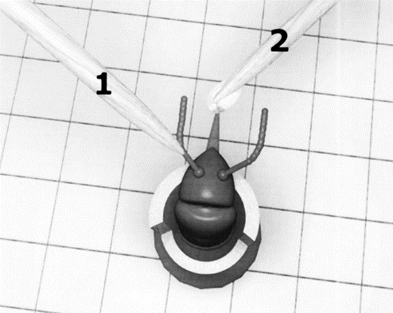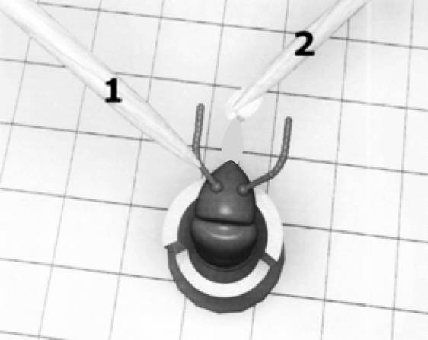
Negative response:
Notice the proboscis is not extended.
Positive response:
Notice the extended proboscis.

If a bee’s proboscis extends at a low concentration of sugar, we conclude that the bee has high ability to detect sugar. In other words, these bees think a relatively low concentration of sugar is worth collecting. If a bee has a high PER threshold, it will take a high concentration of sugar to elicit the PER. These bees are like people with a sweet tooth. If it isn’t really sweet, they don’t want it.

Make a prediction about a bee’s ability to detect sugar and their foraging habits by filling in the table.
Sugar concentration needed to elicit response  (low or high) | Ability to detect sugar  (low or high) | PER threshold  (low or high) | Predicted foraging behavior  (nectar or pollen)
Low
High

The student decides to use the bees from experiment 1 and test their ability to detect sugar using the PER method. Refer back to question 3 in Activity 1 for the two groups of bees.

- Which numbered bees do you predict would have high PER thresholds?

- Which numbered bees would have low PER thresholds?

Examine graph 1 to evaluate your earlier prediction and the student’s hypothesis for the PER experiement.

Graph 1:

Pollen collectors (Bee 10, 17, 37, 42)
Nectar collectors (Bee 23, 26, 34, 44)
10 %
30 %
50 %
Concentration of sucrose solution
Proportion of bees responding

- Does the evidence in the graph support the student’s hypothesis? Explain.

Student’s hypothesis: If a bee is a nectar collector, then that bee is more likely to be able to detect high concentrations of sugar. Conversely, if a bee is a pollen or water collector, then that bee is more likely to respond to a lower concentration of sugar.

Activity 3: Could genes determine a bee’s foraging behavior?
We have learned that bees vary in their threshold response to sugar. Could there be a genetic component to explain this difference in ability to perceive sweetness?

To test this idea, you will learn the process of DNA fingerprinting and analyze DNA from a practice case. Next, you will analyze the DNA from a pollen collector and a nectar collector to determine if there is a difference in their genes. You will then use DNA analysis to classify unknown bees as pollen or nectar collectors.
The Process of Gel Electrophoresis and DNA Fingerprinting Analysis
Gel electrophoresis is a process where DNA fragments of different sizes are separated and analyzed. Before analyzing DNA from your bees, you will learn the steps of DNA fingerprinting from the simulation “The Case of the Licked Lollipop”

Use the link below to describe the purpose of each step of DNA fingerprinting as well as to solve the case.
http://www.pbslearningmedia.org/asset/tdc02_int_creatednafp2/

Step | Purpose
Pour restriction enzymes into DNA | Ex) Enzymes act like scissors cutting DNA at specific places in the DNA code
Pour agarose gel into tray
Pour DNA into tray
** Note: DNA is typically loaded into a slot in the agarose using a pipet
Begin electrophoresis
Place nylon membrane on gel
Add probes to nylon membrane
Place x-ray film on top of nylon film
Develop film and analyze

- Who is the culprit in the case of the Licked Lollipop? ________________________________

Activity 4: Analyzing the DNA from known bees

While the genes responsible for pollen collecting and nectar collecting are still being researched, the following activity simulates how DNA testing might one day be used to visualize the genetic differences between these two strains. In this simulation, you have been given DNA from a pollen collector, a nectar collector, and a sample of DNA showing the action of the restriction enzyme, BamHI. BamHI binds at the recognition sequence 5'-GGATCC-3', and cleaves these sequences just after the 5'-guanine on each strand.
G | T | A | G | G | A | T | C | C | T
C | A | T | C | C | T | A | G | G | A
A DNA sample cut is shown here:

Cut the DNA segments from the pollen and nectar collectors in the same manner as shown in the sample by drawing lines in the appropriate places. Each line represents a cut in the DNA.

DNA Sample of pollen collector:
T | C | C | T | A | G | G | C | T | C | C | T | A | G | G | A | A | T | C | C | T | A | G | G
A | G | G | A | T | C | C | G | A | G | G | A | T | C | C | T | T | A | G | G | A | T | C | C

DNA Sample of nectar collector:
T | T | C | T | A | G | T | C | T | C | C | T | A | G | G | A | A | T | G | C | T | A | G | T
A | A | G | A | T | C | A | G | A | G | G | A | T | C | C | T | T | A | C | G | A | T | C | A

Fill in the table based on the cuts above.
 | Pollen collector | Nectar collector
Number of cuts in DNA
Number of segments of DNA

- How does the number of cuts in the pollen collector’s DNA compare to the nectar collector’s DNA?

- How will this affect the number of fragments formed on the gel electrophoresis?

Activity 5: Using a gel electrophoresis simulation to identify unknown bees

Materials:
- gel electrophoresis card
- small bowl
- water
- 0.5 tsp washing soda
- plastic spoon to stir

The card represents a gel tray from the DNA electrophoresis of four unknown bees. Your task is to analyze the DNA from bees 1-4 and determine which bees are pollen collectors and which bees are nectar collectors by comparing the results to the known bees from Activity 4.

Procedure:
- Fill bowl approximately 1/2 full with water, add 0.5 tsp of washing soda solution. Mix with spoon.
- Dip card into solution until pink dots become visible and quickly remove it.
- Briefly sketch your results into the data table.

Data:
positive
negative
Bee 1
Bee 2
Bee 3
Bee 4
800
600
400
200
100
50
Standard

- Why do the various segments of DNA separate out along the tray?

- Large pieces of DNA would be found toward which end of the gel tray? Why?

- Using the DNA samples from Activity 4, identify which bees from your gel electrophoresis would be…

  - Pollen collectors _______________________

  - Nectar collectors _______________________

- Which bee(s) do you think would be better pollinators? How did you determine this?

Reflection and Application to Agriculture:

- How might a bee’s foraging behavior impact their pollination or honey production potential?

- Genetics are partially responsible for bees’ foraging preference. How might the beekeeping industry use this to their advantage?

