To make the “gel electrophoresis” cards:

- Photocopy the “gel electrophoresis” card template onto card stock**. The gel electrophoresis template has 4 cards per page; cut along the dotted lines to separate the cards.
**Note: We suggest using card stock as copy paper will not stand up well to the washing soda solution.

Apply phenolphthalein to a Q-tip or the eraser end of a pencil. Place dots of phenolphthalein in the correct places on the gel electrophoresis cards. See sample below where “x” indicates where to place a dot of phenolphthalein.

After application, the phenolphthalein will dry as a transparent dot on the card. Place in a plastic bag until ready to use.
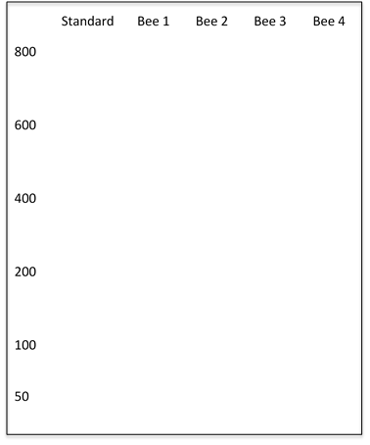
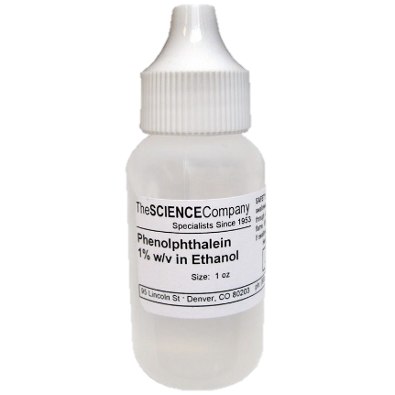
Bee 1
Bee 2
Bee 3
Bee 4
800
600
400
200
100
50
Standard
x
x
x
x
x
x
x
x
x
x
x
x
x
x
x
x
x
x

Note: Students may be concerned that the placement of the DNA pieces do not exactly match each other as they would other types of DNA activities such as identifying DNA from a crime scene. In this type of analysis, researchers are looking for the number of pieces of DNA that result from the enzyme activity and not the size/placement of the DNA.

Bee 1
Bee 2
Bee 3
Bee 4
800
600
400
200
100
50
Standard
Bee 1
Bee 2
Bee 3
Bee 4
800
600
400
200
100
50
Standard
Bee 1
Bee 2
Bee 3
Bee 4
800
600
400
200
100
50
Standard
Bee 1
Bee 2
Bee 3
Bee 4
800
600
400
200
100
50
Standard
Gel electrophoresis lab procedures:
Each group will need 1 bowl, water, 0.5 teaspoon of washing soda, a spoon, and 1 gel electrophoresis card.

- Fill bowl approximately ½ full with water, add ½ tsp of washing soda solution. Mix with spoon.
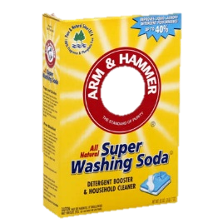
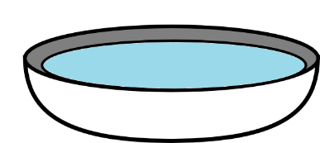

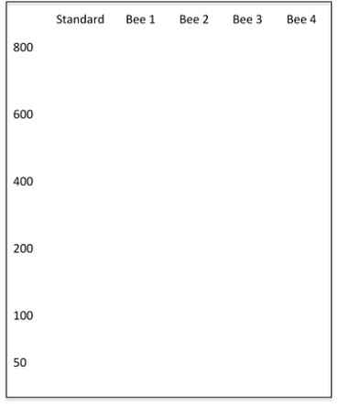
- Dip card into solution until pink dots become visible and quickly remove it.
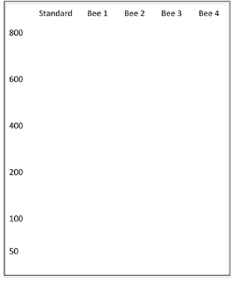

- Record location of “DNA bands” on student worksheet.

