ITEMS FOR EDIBLE LANDFORMS
- Icing - I purchase Walmart ready made icing. The icing will be used for water and grass. (It took 4 containers of icing for 20 students.)
- Food Coloring - green and blue (use this for coloring the icing) I bought mine at the dollar tree)
- Paper plates
- Plastic spoon or knife for smoothing icing
- Graham Crackers - Continents - 1 whole cracker per student
- Vanilla Wafers - Island - 1-2 per student
- Mini Marshmallows - Icebergs - about 3 per student
- Chocolate Chips - hills - 5-6 per student
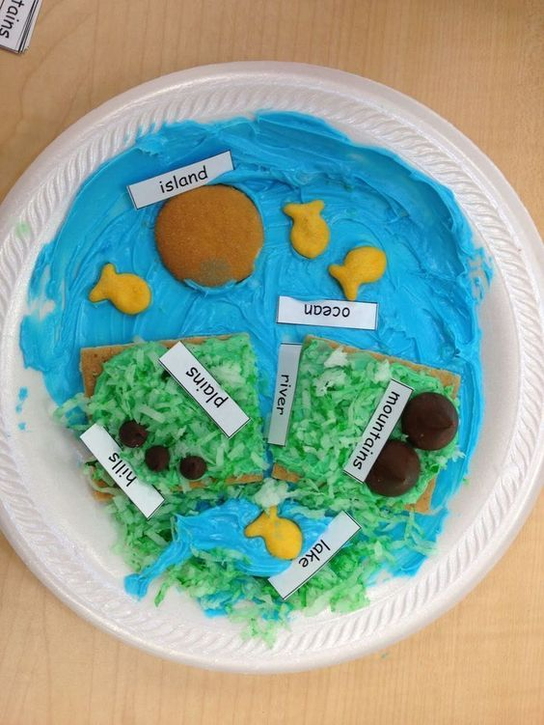
- Hershey Kisses - Mountains (You can also use mini Tootsie Rolls) 3-4 per student
- Goldfish - fish for oceans - 3-4 per student
- Raisins for rocks
- Pretzels for trees
- Coconut died green - (optional) use for grass. My students did not like coconut, so I just colored my icing green.
OPTIONS:
- Students can make theirs like the picture.
- Give students specific landforms to make
- Give students free reign. Let them design their landforms and then have then describe their design to you. This lets the teacher know if the students have an understanding of the concept.

