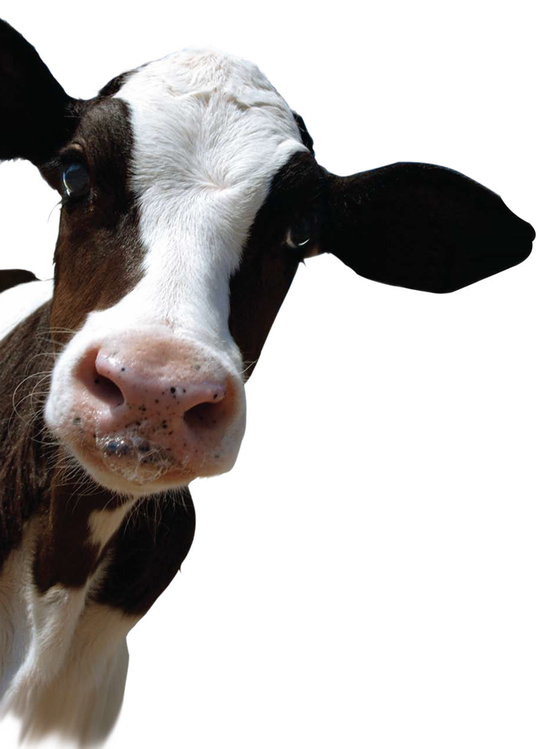 | Kristyna M. Oates  Youth Development and Agricultural Education  College of Agriculture, Purdue University  Phone: (765) 494-8523  E-Mail: koates@purdue.edu

From cow to Cup
Exploring Careers in the Dairy Industry

Overview
The Agriculture in the Classroom program exists in 25 different states across America, including Indiana. Within the state of Indiana, Indiana Farm Bureau is in charge of managing the program and its volunteers. They are often very active in grade school and middle school classrooms, but the program is lacking at the high school level. While the program has had success, the experiences of student can often vary due to the range of knowledge and teaching experience of the volunteers. Many volunteers work in the agriculture industry, but they do not have any formal teaching experience and there is also a wide range of expertise. In order to assist volunteers and increase the program in high school classrooms, a series of eight interactive eLearning lessons will be developed for AITC. These lessons can be used by volunteers or by high school agriculture teachers throughout Indiana, as well as across the country. The overall goal of these lessons is to increase engagement in the AITC program within high school classrooms, increase agricultural literacy, and knowledge of agricultural careers in students using this curriculum.
For this project, a grant from the United States Department of Agriculture (USDA) was awarded to Purdue University to produce online eLearning modules for high school students in agriculture classes, and make these lessons available to agricultural education teachers, and AITC volunteers. These lessons will allow students to explore the career possibilities in the agriculture industry, specifically the dairy industry. It is important that students explore the career possibilities within agriculture because there is always a need for skilled workers. A 2015 study commissioned by USDA’s National Institute of Food and Agriculture (NIFA) found that there will be 57,900 average annual job openings between 2015 and 2020 (Goecker, Smith, Fernandez, Ali, & Goetz Theller, 2015). The study determined that 27% of these jobs will be in science, technology, engineering, and math (STEM). However, even with all of the opportunities, the study found that there would be a 41% shortfall of U.S. graduates in food, renewable energy, and environmental specialties (Mercier, 2015). Clearly, there is a need for skilled employees in the agriculture industry. In addition to a growing demand for jobs, career exploration materials may be able to better target potential students through the use of more engaging methods. In today’s world, there are over 3 billion internet users and around 40% of the world’s population has an internet connection ("Internet Users," 2000). Teenagers between 16 and 24 spend more than 27 hours a week on the Internet (Anderson, 2015). With the number of college aged individuals using the Internet, college programs should focus their efforts on reaching a wide audience of potential students by implementing more Internet resources. By providing the materials in an engaging manner, high school students learn more regarding career opportunities available in agriculture. As a result of the creation of these lessons, AITC will have tools, which they currently do not have, to target this particular age group. These lessons will serve as a model, which can be applied to other areas of the animal agriculture industry.
Since this project is driven by the grant stipulations and the needs of the stakeholders, there are particular parameters that must be followed and goals that must be met. These lessons are being designed for Agriculture in the Classroom program (AITC) volunteers to use or by high school agriculture teachers to use in their classrooms. The client has determined that the modules will be designed in Articulate Storyline 2 and they will be distributed on the Purdue University Youth Development and Agricultural Education website In addition to the careers modules, there is also a series of modules focused on the science and management in the dairy industry. Considering Horton’s techniques for goals, it was the client who identified that the high school program of AITC was in need of assistance (Horton, 2012).

Explanation of Content
William Horton’s model was used to structure and frame these lessons. In this model there are four components: Absorb, Do, Connect, and Assess. In the Absorb section, content is delivered to the students, which is followed by a Do activity, and a Connect activity to make associations between other learning concepts and sources. The fourth section is the Assess section, which provides the learner with a particular question or task, dictated by the objective, which can determine the level of knowledge gained. Specific words are chosen and correspond to specific Absorb, Do, Connect, and Assess activities. The material and activities were designed to engage students while delivering curriculum by a unique method. Image 1 shows the lesson modules that will be offered in this unit and Table 1 shows objectives that are used throughout the Cow to Cup lessons. If you would like to know specific about what is contained in each slide, see the Slide Index section for details.
The unit will consist of four lessons that can be taught individually or as a complete unit. For those who choose to implement the unit in a classroom setting, adjusted lessons are provided with a corresponding a worksheet and quiz for each lesson. It is also the instructor’s choice if they would like students to complete the units in class as a part of a larger unit, complete the lessons under the instruction of a substitute, as a homework assignment, etc. Students will benefit from the completion of the lessons and activities and will gain knowledge of the dairy industry while also exploring associated careers. It is encouraged that all lessons are completed, but educators may decide what is appropriate and fitting for their classroom and students. Each lesson contains definitions that pertain to that specific stage in dairy production, word scramble, main content for that industry stage, several short answer questions, three careers with information and a video interview with a professional, career exploration activity, and a five question quiz. If the classroom version is being used, the activities and quiz worksheets can be downloaded and printed at the beginning of the lesson. If the independent version is being used, please note that the passing score is set at 80%, but instructors may wish to adjust the passing score to fit the needs of their students and classroom environment.
Table 1: From Cow to Cup Lesson Objectives
Topic # | Topic Title | Type of Objective | Objective
1 | Terminology | Know | Teach to define terms that pertain to the dairy industry to high school students who participate in agriculture classes.
2 | Basic industry practices | Know | Teach to how to identify steps in the overall production process of the dairy industry to high school students who participate in agriculture classes.
3 | Career options | Know | Teach to identify careers in the dairy production process to high school students who participate in agriculture classes.
4 | Career pieces | Know | Teach to recognize where careers fit into the dairy production process to high school students who participate in agriculture classes.
5 | Choosing a path | Believe | Teach how to choose a dairy career option to pursue after high school to students who participate in high school agriculture classes.

Image 1: Lesson Topics

Standards
In an effort to provide useful resources to educators, the lessons were also correlated to academic standards. Table 2 indicates the high school courses, corresponding Indiana academic standards, and which lessons can meet these requirements.
Table 2: Academic Standards
Course Title | DOE Code | Grade Level | Domain | Standard | Corresponding Lesson Modules
Advance Life Sciences: Animals | 5070 | 11-12 | Careers | ALSA-5.1, ALSA-5.2, ALSA-5.3, ALSA-5.4 | 1, 2, 3, 4
Advance Life Sciences: Foods | 5072 | 11-12 | Careers | ALSF-7.1, ALSF-7.2, ALSF-7.3, ALSF-7.4 | 3, 4
Animal Sciences | 5008 | 9-12 | Careers | AS-10.1, AS-10.2, | 1, 2, 3, 4
Food Science | 5102 | 9-12 | Careers | FS-11.1, FS-11.2, FS-11.3, FS-11.4 | 1, 2, 3, 4
Agribusiness Management | 5002 | 11-12 | Careers | AM-9.1, AM-9.2, AM-9.3, AM-9.4 | 1, 2, 3, 4
Introduction to Agriculture, Food, and Natural Resources | 5060 | 9-10 | Careers | IAFNR-1.1, IAFNR-1.2, IAFNR-1.3, IAFNR-1.4 | 1, 2, 3, 4

Troubleshooting
While the lessons were designed to have minimal issues, technology can sometimes present difficulties. If implementing the lessons or unit in a classroom setting, it is encouraged that educators to preview the information and modules in order to understand the material, what students may experience, and what questions they may have (see ‘Common Questions’ for frequently asked questions and answers). If a lesson will not load, please try refreshing the page. If this does not fix the issue, try accessing the lessons using a different internet browser. These lessons have been proven to load correctly in Internet Explorer, Mozilla Firefox, Google Chrome, and Safari. If you are progressing through the lesson and find that a button does not work, try using the menu on the left hand side to navigate to the desired slide. If you find that there is an issue with the lesson modules, please contact the Purdue University Department of Youth Development and Agricultural Education at (765) 494-8523.

Common Questions about the Dairy Industry
Discussion of the animal agriculture industry can raise questions from students and participants. Your students may ask questions about material in the lesson and inquire more about module content. Below are commonly asked questions regarding the dairy industry and the production of dairy food products that may help you in answering student questions.

Q: How are animals cared for when they become sick?
A: Great care is taken in preventing illness in a cattle herd. Occasionally when a cow or calf becomes ill, a veterinarian will administer antibiotics or other medicine as needed. Sick animals are housed separately from the herd and they are not milked with the rest of the herd in order to prevent the spread of disease or contamination.

Q: Shouldn’t dairy calves be kept with their mothers?
A: Calves are an important part of future farm operations, so it is very important that calves are kept healthy. When calves are removed from their mother, they are housed in a clean, individual pen. This helps to prevent the spread of disease between mother and calf. Calves are fed a specialized milk replacer that meets all of their nutritional needs.

Q: Is it painful for cows to be milked?
A: Cow comfort is an important part of modern dairy operations. Newer milking technology allows for improved cow comfort and maximum productivity. The machines remove just the right amount of milk and it does not hurt the cow at all. In fact, when it is time to be milked, cows are often seen making their way to the milking barn without any prompting – they enjoy it!

Q: Is it true that dairy farms are bad for the environment?
A: No. Dairy farmers care about the environment. Farmers work to ensure that surrounding water sources (rivers, streams, etc.) remain safe by using preventative methods such as crops, buffer strips, and catch basins. Water sources are also inspected regularly by state and local government agencies. Farmers also have manure management programs in place, which help to minimize odors as much as possible.

Q: Is it true smaller farms take better care of their cows?
A: No, both large and small farms properly care for all their animals. Cows come first on a farm, regardless of farm size.

Q: Are hormones added to milk?
A: No. Hormones are naturally present in many food products. There are synthetic hormones, such as rbST, which may be given to cows to help with milk production. rbST is a hormone that occurs naturally in all cows. Some farmers may choose to use this management tool.

Q: Is rbST safe?
A: Yes. The FDA approved this synthetic hormone in the 1990s and the scientific community has confirmed its safety repeatedly. Even if there was any trace amount of this hormone in the milk, the pasteurization process destroys it. There is no significant difference between the milk of cows that have been given this hormone and the milk of cows that have not received rbST.

Q: What is lactose intolerance?
A: Lactose intolerance is a dietary issue where an individual has a difficult time digesting the sugar, lactose. Individuals may suffer from stomachaches, bloating, or other intestinal issues. If you believe you may suffer form lactose intolerance, consult your doctor.

Q: Is organic milk better than conventional milk?
A: There is no nutritional or composition difference between organic and regular milk. Both beverages contain the same nutritional content and are a part of a balanced diet. You can find more information about labeling requirements at the USDA website and you can find the website URL in Table 3.

Where Can I Find the Lessons?
The lessons, both independent versions and classroom versions, classroom materials, and the instructor’s guide can be found on the Purdue University Youth Development and Agricultural Education website as well as on the authors website. The links for the lessons and materials can be found in the Table 3. Please note that there are two versions of these versions of these lessons. The independent lessons are designed for independent users or for individuals who wish to use these lessons as a supplemental resource or completion grade assignment. The classroom lessons are intended for use in a classroom setting and the activities and quiz are separate from the online modules. They can be downloaded within the lesson and turned in to the instructor for easy grading.

Table 3: URL of Cow to Cup Lessons
Source | URL
Purdue University | https://ag.purdue.edu/ydae/Pages/default.aspx
Author’s Website | http://agrieducation.weebly.com

Additional Sources of Information
In addition to resources provided in each lesson, you may want to provide your students with additional information or who are looking for further resources about the dairy industry. Table 4 contains a few sources of information educators and learners may find useful. When searching for resources about the dairy industry, ensure that they are credible by looking for “.edu” or “.gov” ending the URL.

Table 4: Additional Resources
Name | URL
Ag Explorer | https://www.agexplorer.com
American Dairy Association Indiana | https://winnersdrinkmilk.com
Dairy Farmers of America | http://www.dfamilk.com
American Dairy Association Mideast | https://www.drink-milk.com
Midwest Dairy Association | https://www.midwestdairy.com
International Dairy Foods Association | http://www.idfa.org
Bureau of Labor Statistics | https://www.bls.gov
Food and Drug Administration | https://www.fda.gov
United States Department of Agriculture | https://www.usda.gov

Slide Index
To allow for instructors to see what information is contained in each lesson and where it is located in the unit, a slide index has been provided. Tables 5, 6, 7, and 8 outline what is contained in each Independent lesson and Tables 9, 10, 11, and 12 detail what is contained in the classroom lessons.

Table 5: Breeding and Gestation Independent Lesson Index
Slide Number | Contents
1, 2 | Title Slide, Overview
3 | Definitions
4 | Word Scramble
5 | Production Process Stages
6 | Production Stage Characteristics
7 | Video and Short Answer Question
8 | Associated Careers
9 | Video and Short Answer Question
10 | Career Menu
11,12 | Career Information – Dairy Farm Manager
13,14 | Career Information – Lactation Physiologist
15, 16 | Career Information – Reproduction Specialist
17 | Where do you see yourself? Activity

Table 5: Breeding and Gestation Independent Lesson Index Continued
18 | Career Summary Short Answer Question
19 | Career Summary Chart
20 | Exploring Careers Activity
21 | Additional Resources
22 | Quiz Instructions
23, 24, 25, 26, 27 | Quiz Questions 1 to 5
28 | Quiz Results Slide
29, 30 | Thank you to Students and Sponsors

Table 6: Product Production Independent Lesson Index
Slide Number | Contents
1, 2 | Title Slide, Overview
3 | Definitions
4 | Word Scramble
5 | Production Process Stages
6 | Production Stage Characteristics
7 | Video and Short Answer Question
8 | Associated Careers
9 | Video and Short Answer Question
10 | Career Menu
11,12 | Career Information – Dairy Nutritionist
13,14, 15 | Career Information – Animal Welfare and Behavior Specialist
16, 17 | Career Information – Agriculture Engineer
18 | Where do you see yourself? Activity
19 | Career Summary Short Answer Question
20 | Career Summary Chart
21 | Exploring Careers Activity
22 | Additional Resources
23 | Quiz Instructions
24, 25, 26, 27, 28 | Quiz Questions 1 to 5
29 | Quiz Results Slide
30, 31 | Thank you to Students and Sponsors

Table 7: Product Processing Independent Lesson Index
Slide Number | Contents
1, 2 | Title Slide, Overview
3 | Definitions
4 | Word Scramble
5 | Production Process Stages
6 | Production Stage Characteristics
Table 7: Product Processing Independent Lesson Index Continued
7 | Video and Short Answer Question
8 | Associated Careers
9 | Video and Short Answer Question
10 | Career Menu
11,12 | Career Information – Dairy Food Manufacturing Specialist
13,14 | Career Information – Food Handling Specialist
15, 16 | Career Information – BOAH Inspector
17 | Where do you see yourself? Activity
18 | Career Summary Short Answer Question
19 | Career Summary Chart
20 | Exploring Careers Activity
21 | Additional Resources
22 | Quiz Instructions
23, 24, 25, 26, 27 | Quiz Questions 1 to 5
28 | Quiz Results Slide
29, 30 | Thank you to Students and Sponsors

Table 8: Retail of Product Independent Lesson Index
Slide Number | Contents
1, 2 | Title Slide, Overview
3 | Definitions
4 | Word Scramble
5 | Production Process Stages
6 | Production Stage Characteristics
7 | Video and Short Answer Question
8 | Associated Careers
9 | Video and Short Answer Question
10 | Career Menu
11,12 | Career Information – Human Nutritionist
13,14 | Career Information – Epidemiologist
15, 16, 17 | Career Information – Milk Promotion Specialist
18 | Where do you see yourself? Activity
19 | Career Summary Short Answer Question
20 | Career Summary Chart
21 | Exploring Careers Activity
22 | Additional Resources
23 | Quiz Instructions
24, 25, 26, 27, 18 | Quiz Questions 1 to 5
29 | Quiz Results Slide
30, 31 | Thank you to Students and Sponsors
Table 9: Breeding and Gestation Classroom Lesson Index
Slide Number | Contents
1,2 | Title Slide, Overview
3 | Lesson Documents
4 | Definitions
5 | Production Process Stages
6 | Production Stage Characteristics
7 | Your Thoughts Video 1
8 | Associated Careers
9 | Your Thoughts Video 2
10 | Career Menu
11, 12 | Career information – Dairy Farm Manager
13, 14 | Career information – Lactation Physiologist
15, 16 | Career information – Reproduction Specialist
17 | Where do you see yourself? Activity
18 | Career Summary
19 | Exploring Careers Activity
20 | Additional Resources
21, 22 | Thank you to Students and Sponsors

Table 10: Product Production Classroom Lesson Index
Slide Number | Contents
1,2 | Title Slide, Overview
3 | Lesson Documents
4 | Definitions
5 | Production Process Stages
6 | Production Stage Characteristics
7 | Your Thoughts Video 1
8 | Associated Careers
9 | Your Thoughts Video 2
10 | Career Menu
11, 12 | Career information – Dairy Nutritionist
13, 14, 15 | Career information – Welfare Specialist
16, 17 | Career information – Agriculture Engineer
18 | Where do you see yourself? Activity
19 | Career Summary
20 | Exploring Careers Activity
21 | Additional Resources
22, 23 | Thank you to Students and Sponsors

Table 11: Product Processing Classroom Lesson Index
Slide Number | Contents
1,2 | Title Slide, Overview
3 | Lesson Documents
4 | Definitions
5 | Production Process Stages
6 | Production Stage Characteristics
7 | Your Thoughts Video 1
8 | Associated Careers
9 | Your Thoughts Video 2
10 | Career Menu
11, 12 | Career information – Dairy Food Manufacturing
13, 14 | Career information – Food Handling Specialist
15, 16 | Career information – BOAH Inspector
17 | Where do you see yourself? Activity
18 | Career Summary
19 | Exploring Careers Activity
20 | Additional Resources
21, 22 | Thank you to Students and Sponsors

Table 12: Retail of Product Classroom Lesson Index
Slide Number | Contents
1,2 | Title Slide, Overview
3 | Lesson Documents
4 | Definitions
5 | Production Process Stages
6 | Production Stage Characteristics
7 | Your Thoughts Video 1
8 | Associated Careers
9 | Your Thoughts Video 2
10 | Career Menu
11, 12 | Career information – Human Nutritionist
13, 14, 15 | Career information – Epidemiologist
16, 17 | Career information – Milk Promotion Specialist
18 | Where do you see yourself? Activity
19 | Career Summary
20 | Exploring Careers Activity
21 | Additional Resources
22, 23 | Thank you to Students and Sponsors

References
Anderson, E. (2015). Teenagers spend 27 hours a week online: how internet use has ballooned in the last decade. Retrieved from http://www.telegraph.co.uk/finance/newsbysector/mediatechnologyandtelecoms/digital-media/11597743/Teenagers-spend-27-hours-a-week-online-how-internet-use-has-ballooned-in-the-last-decade.html
Goecker, A. D., Smith, E., Fernandez, J. M., Ali, R., & Goetz Theller, R. (2015). Employment Opportunities for College Graduates in Food, Agriculture, Renewable Natural Resources, and the Environment. Employment Opportunities. Retrieved from https://www.purdue.edu/usda/employment/
Horton, W. (2012). E-Learning by Design (2 ed.). CA: Pfeiffer.
Internet Users. (2000). Retrieved from http://www.internetlivestats.com/internet-users/
McCullah-Glowacki, C. (2014). Indiana Academic Standards - CTE: Agriculture. Indiana Academic Standards. Retrieved from http://www.doe.in.gov/standards/cte-agriculture
Mercier, S. (2015). Food and Agricultural Education in the United States. AGree: Transforming Food and Ag Policy, 20.

