POLLINATING
YOUNG
MINDS
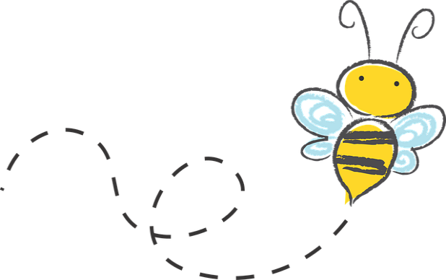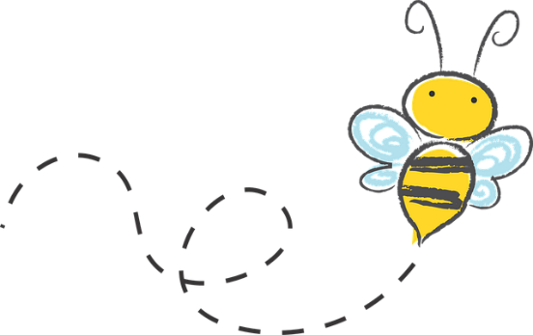

Donna Musick
Damascus, Virginia
I begin with a seed unit before discussing pollinators. The following books are suggestions
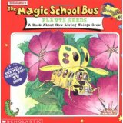Ms. Frizzle’s class is growing a garden, but Phoebe’s plot is empty. Her flowers are at her old school. So, the kids climb aboard the Magic School Bus. They go to Phoebe’s old school to get some of her old flowers, but they end up going inside the flowers. Follow the kid’s colorful adventures as they learn how living things grow.
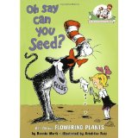 With the able assistance of Thing 1 and Thing 2—and a fleet of Rube Goldbergian vehicles—the Cat in the Hat examines the various parts of plants, seeds, and flowers; basic photosynthesis, and pollination.
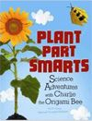Charlie the Origami bee may be new to the bug world, but he knows all about plants. When the other bugs lose their ball, his plant smarts come in handy. Buzz around with Charlie and learn about plant parts. The directions are also included to make an origami bee.
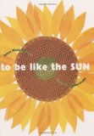To Be Like the Sun is a lovely poem that shares a little girl’s conversation with a sunflower seed as she follows it through the life cycle of the plant. I love how her curiosity reflects the way young kids approach nature and scientific discovery.
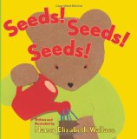Seeds! Seeds! Seeds! is another great book that encourages kids to get involved. In the story Buddy’s grandfather sends him five colorful bags and a note. Each bag has a surprise that helps learn about seeds. Kids can get their own seeds and join in as buddy sorts, collects and eats the seeds from his grandfather.
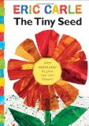 The Tiny Seed follows a single seed as it is whisked away by the autumn wind. On its yearlong journey readers discover all that the tiny seed goes through to eventually become a giant flower.
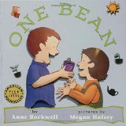 It walks kids through a planting a bean seed and watching it grow. My kids loved this one, because the details very closely mimicked what was happening with our bean seeds.
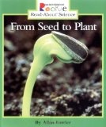 From Seed to Plant is part of the Rookie Read-About Science Series. It is a very simple nonfiction text that is perfect for beginning readers.

Ideas for Seed Unit
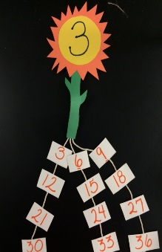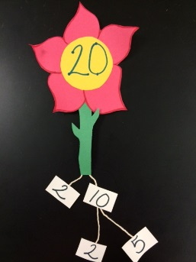
Multiples Factoring
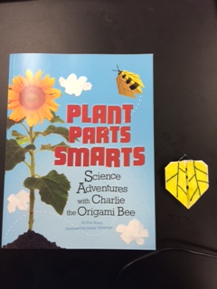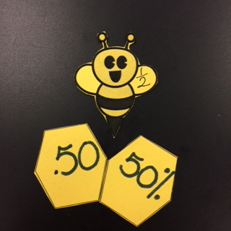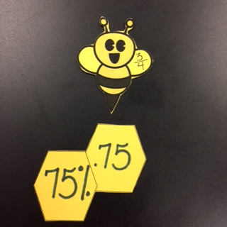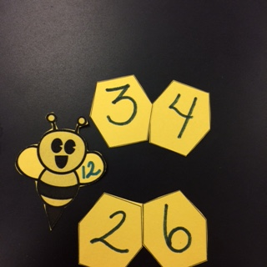
Book fraction/decimal/% Factors

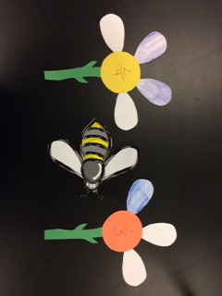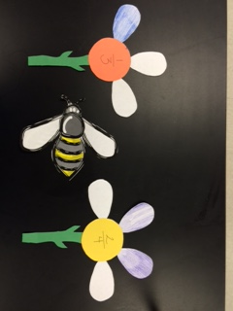
- Greater than and Less Than <

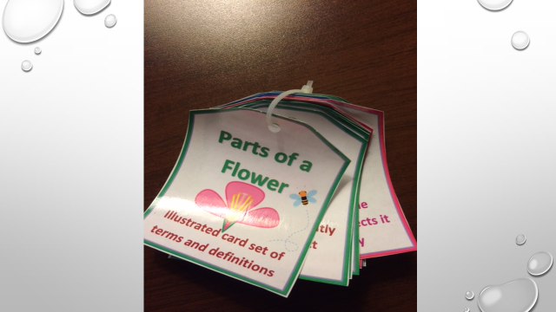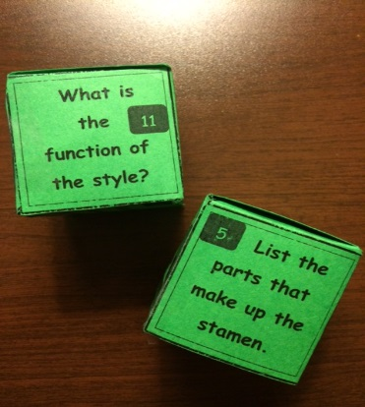

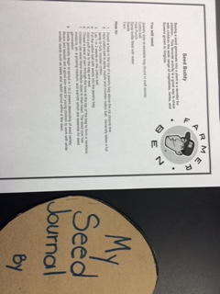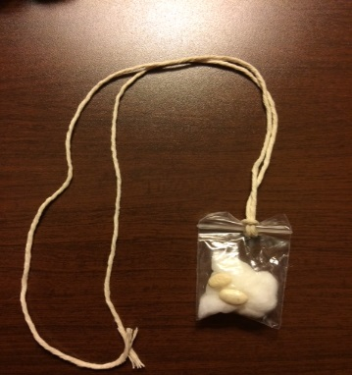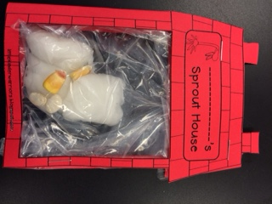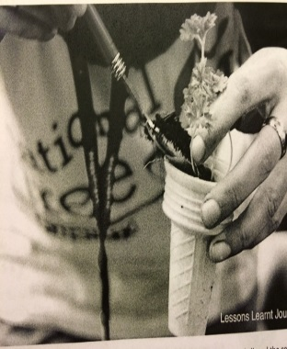

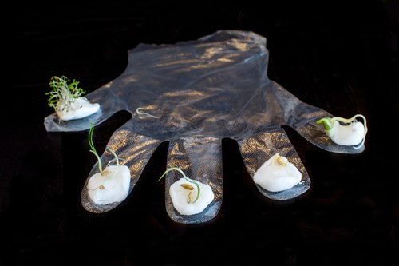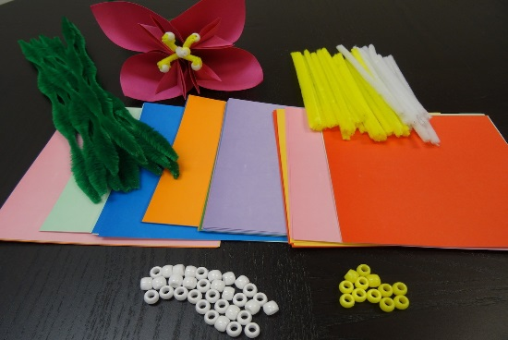

Farming in a Glove Origami Parts of a Flower
(Both kits available from agclassroomstore.com)

What’s the secret to enjoying more blooms and greater harvests? Pollination! To increase the pollination of your garden plants, consider getting a backyard bee house for native solitary bees, such as mason bees and leafcutter bees.

SOLITARY BEES: THE HEROES OF POLLINATION: Most of us grew up learning about the sophisticated social structures of honey bees and bumblebees, and we’ve come to think that their lifestyle represents all bee behavior. The truth is, the world is home to more than 20,000 species of bees, and a whopping 90% of them do not live together in hives.
Instead, most of the world’s bees live alone. Unlike social bees, each female solitary bee has to gather pollen and nectar, build nests, and lay eggs all on her own, without the help of hundreds or thousands of doting workers. And although honey bees tend to get all the credit for keeping our crops going, native solitary bees are almost two to three times more effective pollinators!
So, if 90% of bees don’t live in hives, where do they live? Well, about 70% of solitary bee species nest underground in tunnels and burrows, while the remaining 30% nest aboveground, in holes in logs and stems.
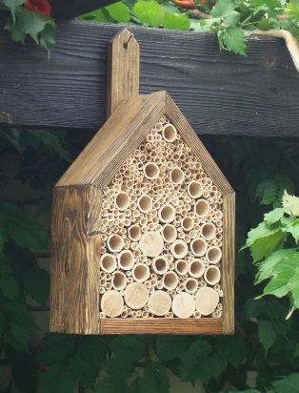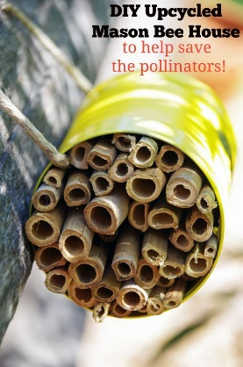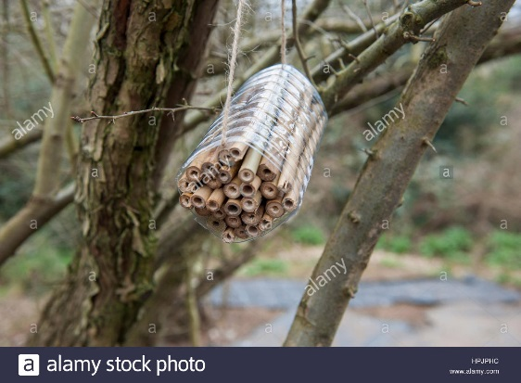

Demonstrating how bees help flowers with Cereal Bee Hive
pollination using Kool Aid
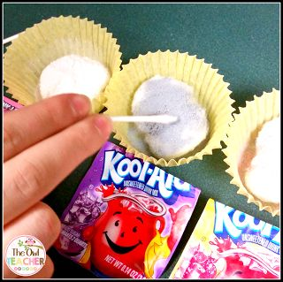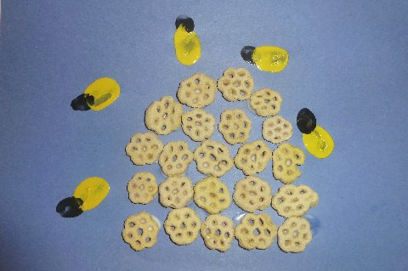

Butterfly Life Cycle
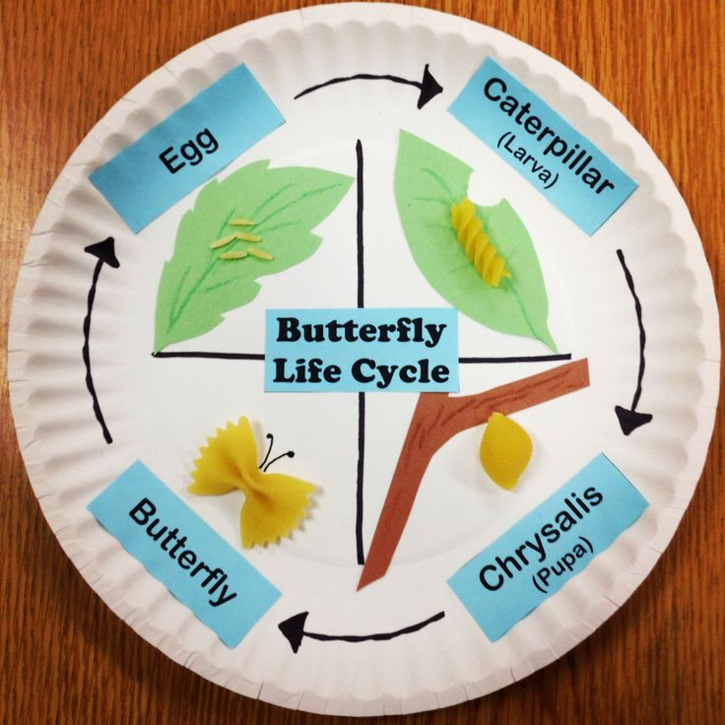

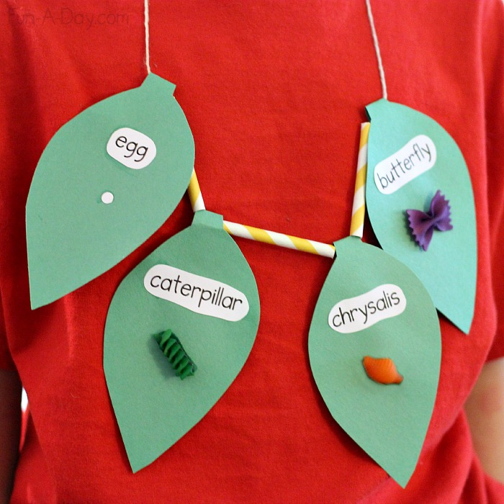

Bats as Pollinators
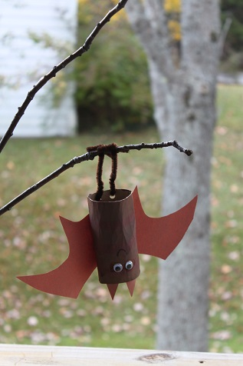
When we think about pollination, it is typically the birds and the bees that come to mind. Most people have no clue that the bat also places a huge role in that process. This takes place on a very large scale around the world. Some areas do depend on the pollination of bats more than others. They include Africa, Asia, and the Pacific Islands.
Bats help with the pollination of many types of fruit in the world. This includes bananas, mangos, and peaches. It is believed that over 500 different types of tropical plants are pollinated successfully every single year through the bats role. The fact that the bats can fly quite a distance before they drop seeds also helps to keep areas of growth highly diversified.
Bats tend to like flowers that don’t give off strong scents or offer bright colors. This is the opposite of what attracts bees. These types of flowers that the bats like also seem to have lots of nectar offered in them. Many experts believe that the birds and bees take the day shift and the bats take the night shift. Everything that we know about pollination in the day time occurs at night with the bats.
It is believed that over 500 different types of tropical plants are pollinated successfully every single year through the bats role.

Since many bats are migratory in nature, they can carry the pollination process great distances. Their movements are believed to continually introduce new plants to various locations out there. Sometimes the growth of them is successful. Other times it isn’t possible for those types of plants or flowers to grow in the new location. The bottom line though is that the bat really does have a substantial role in overall pollination efforts.

These are a few activities that can be modified for your use. Patterns and instructions are included in your packet. Enjoy

