[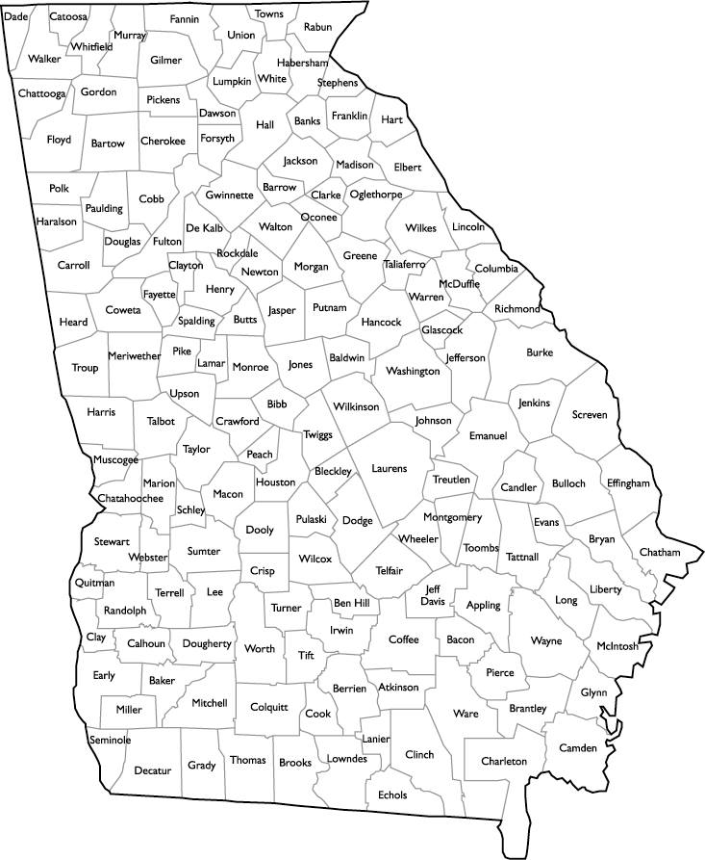](https://www.google.com/url?sa=i&source=images&cd=&cad=rja&uact=8&ved=2ahUKEwjEuvKBvIbbAhXhm-AKHS10ALsQjRx6BAgBEAU&url=http://www.tuckeryellowpages.com/georgiamapbycounties.htm&psig=AOvVaw3qVxUpm8xmA4gxz9G-Kgup&ust=1526430800524241)

County with the most letters____________________

County with the least amount of letters_____________

**Find and color the counties that match the clues:**

*color word

*President’s name

*something a baby wears

*opposite of late

*something you drink

*part of a tree

*something you eat

*soil type

*one of the 5 senses

*body part

*career