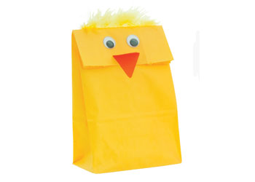
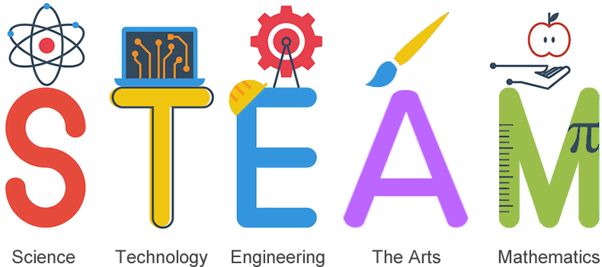

Chicken Paper Bag – Craft Activity
Turn a plain paper bag into a chicken in this fun activity. Students can use different types of materials, including googly eyes, construction paper, feathers, markers, crayons, and cotton balls to create a chicken. STEAM skills such as painting, measuring, cutting and gluing are part of the process.

Activity Steps
- Take a yellow bag. Fill it half way with toy filling. (polyester fiberfill)
- Fold the top of the bag over around 5cm. Then glue down. Allow to dry.
- Attach the eyes to the flap. (glue or use googly eyes with adhesive back)
- Take the orange construction paper and draw a rhombus (approx 5.5cm x 3.5cm).
- Fold the rhombus in half to make the beak and glue along the fold under the eyes.
- Glue a feather horizontally along the top of the chick's head.
- Allow to dry. Then have fun with your new friend!

Materials Required
Small paper bags (snack size) Googly eyes (glue on or adhesive back)
Feathers Polyester fiberfill
Orange construction paper School glue or glue sticks
Ruler Pencil

STEAM CHALLENGE
Create a hand puppet. Include measurements for each step of the process. Brainstorm alternative materials for a creative craft project.
Suggestions:____________________________________________________________________
______________________________________________________________________________
______________________________________________________________________________
______________________________________________________________________________
______________________________________________________________________________

